BDA SPARK EXERCISES
Experiment1 : Word Count using PySpark RDD
Objective: Count word frequencies in a text file.
Key Concepts: RDDs, transformations, actions, basic aggregations
Aim
To implement a Word Count program using PySpark RDDs and perform text analysis by:
- Counting word frequencies.
- Filtering words with length greater than 3 characters.
- Finding the top 10 most frequent words.
- Removing common stop words.

Procedure
- Install and configure PySpark in the Ubuntu environment.
- Create a text input file (sample.txt) containing sample data.
- Create a Spark application using SparkSession.
- Load the text file using Spark RDD (textFile()).
- Split the text into individual words using flatMap().
- Remove unwanted stop words using filter().
- Select only words having more than 3 characters.
- Convert each word into key-value pairs (word, 1) using map().
- Count the frequency of each word using reduceByKey().
- Sort and display the top 10 most frequent words.
- Stop the Spark session after execution.

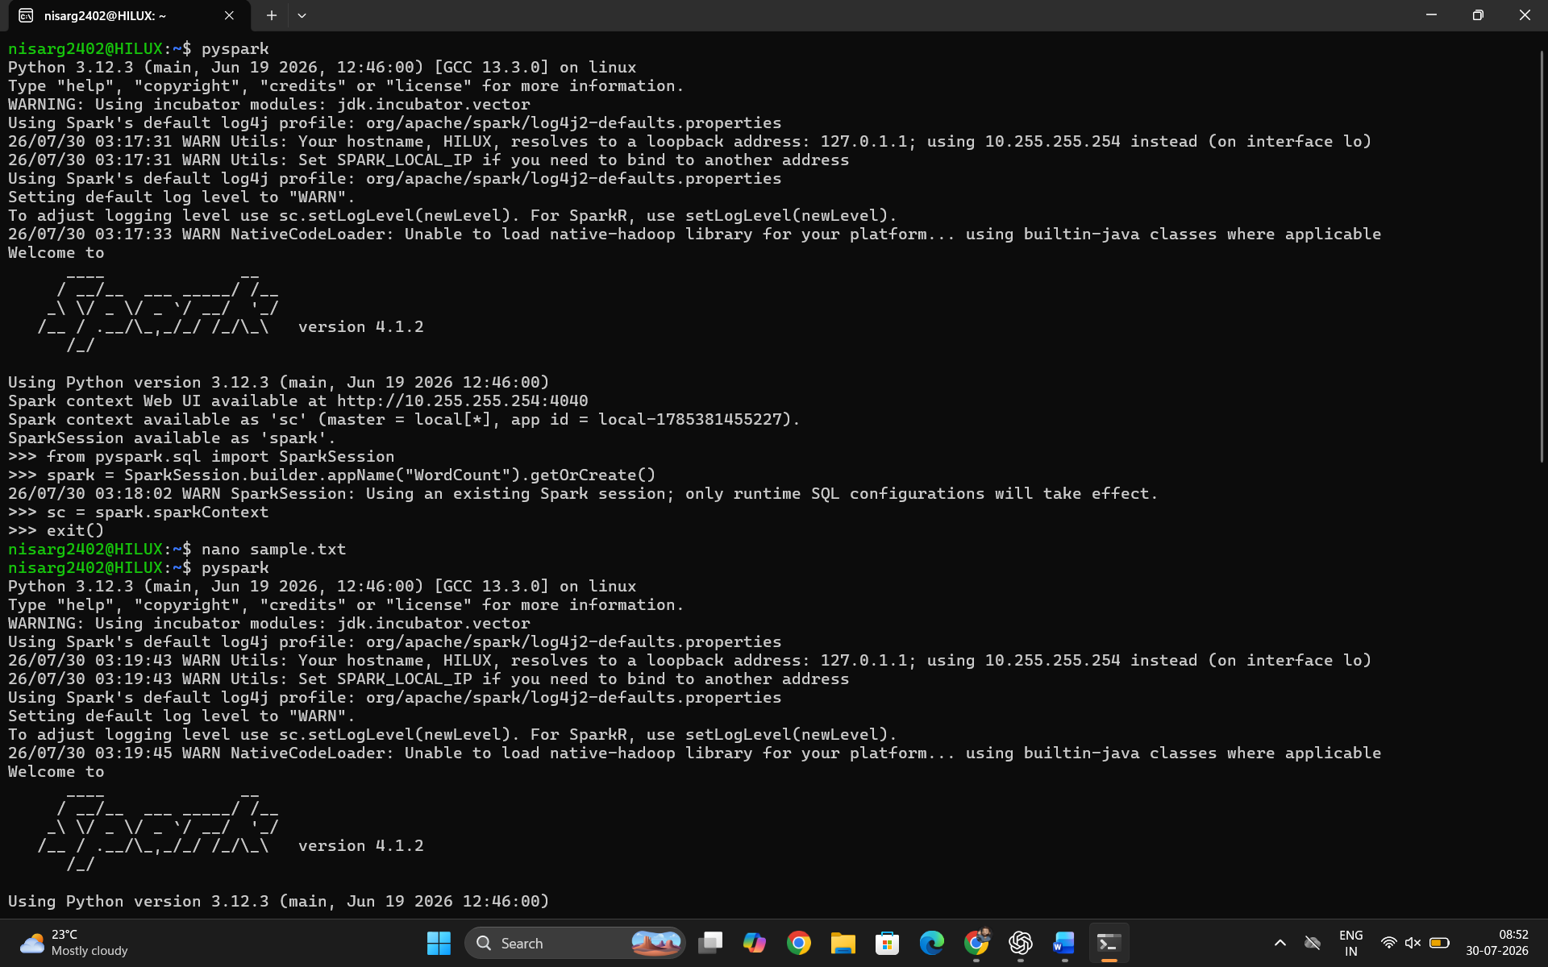
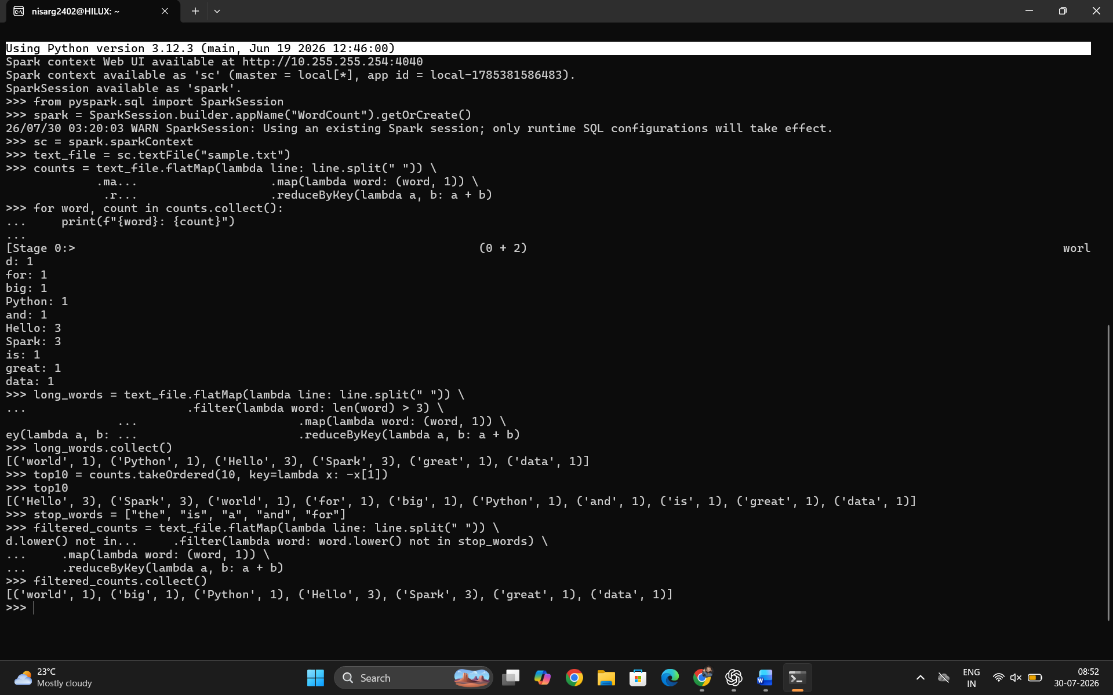
Conclusion
The Word Count application was successfully implemented using PySpark RDD operations. The program demonstrated important Spark concepts such as RDD creation, transformations, filtering, mapping, aggregation, and actions. The modified program efficiently removed stop words, considered only meaningful words with length greater than 3 characters, and identified the top 10 frequently occurring words in the input text. This experiment shows how Apache Spark can be used for scalable text processing and big data analytics.
Experiment 2: Sales Data Analysis using PySpark DataFrame API
Objective: Analyze sales data to find top products and revenue trends.
Key Concepts: DataFrames, SQL-like operations, aggregations.
Aim
To implement Sales Data Analysis using PySpark DataFrame API and perform data analytics operations such as:
- Calculating total revenue by products and cities.
- Finding the top 5 best-selling products.
- Calculating month-over-month revenue growth.
- Identifying products with the highest average order value.

Procedure
- Install and configure Apache Spark and PySpark environment.
- Create a Spark application using SparkSession.
- Create sample sales data using PySpark Row objects.
- Convert the sales data into a Spark DataFrame.
- Add a new column to calculate revenue using:
Revenue = Price × Quantity
- Perform aggregation operations using groupBy() and agg().
- Analyze product-wise and city-wise revenue.
- Sort products based on sales quantity to find the top 5 selling products.
- Extract monthly revenue and calculate month-over-month growth using window functions.
- Calculate average order value for each product.
- Display the analysis results.
- Stop the Spark session after execution.

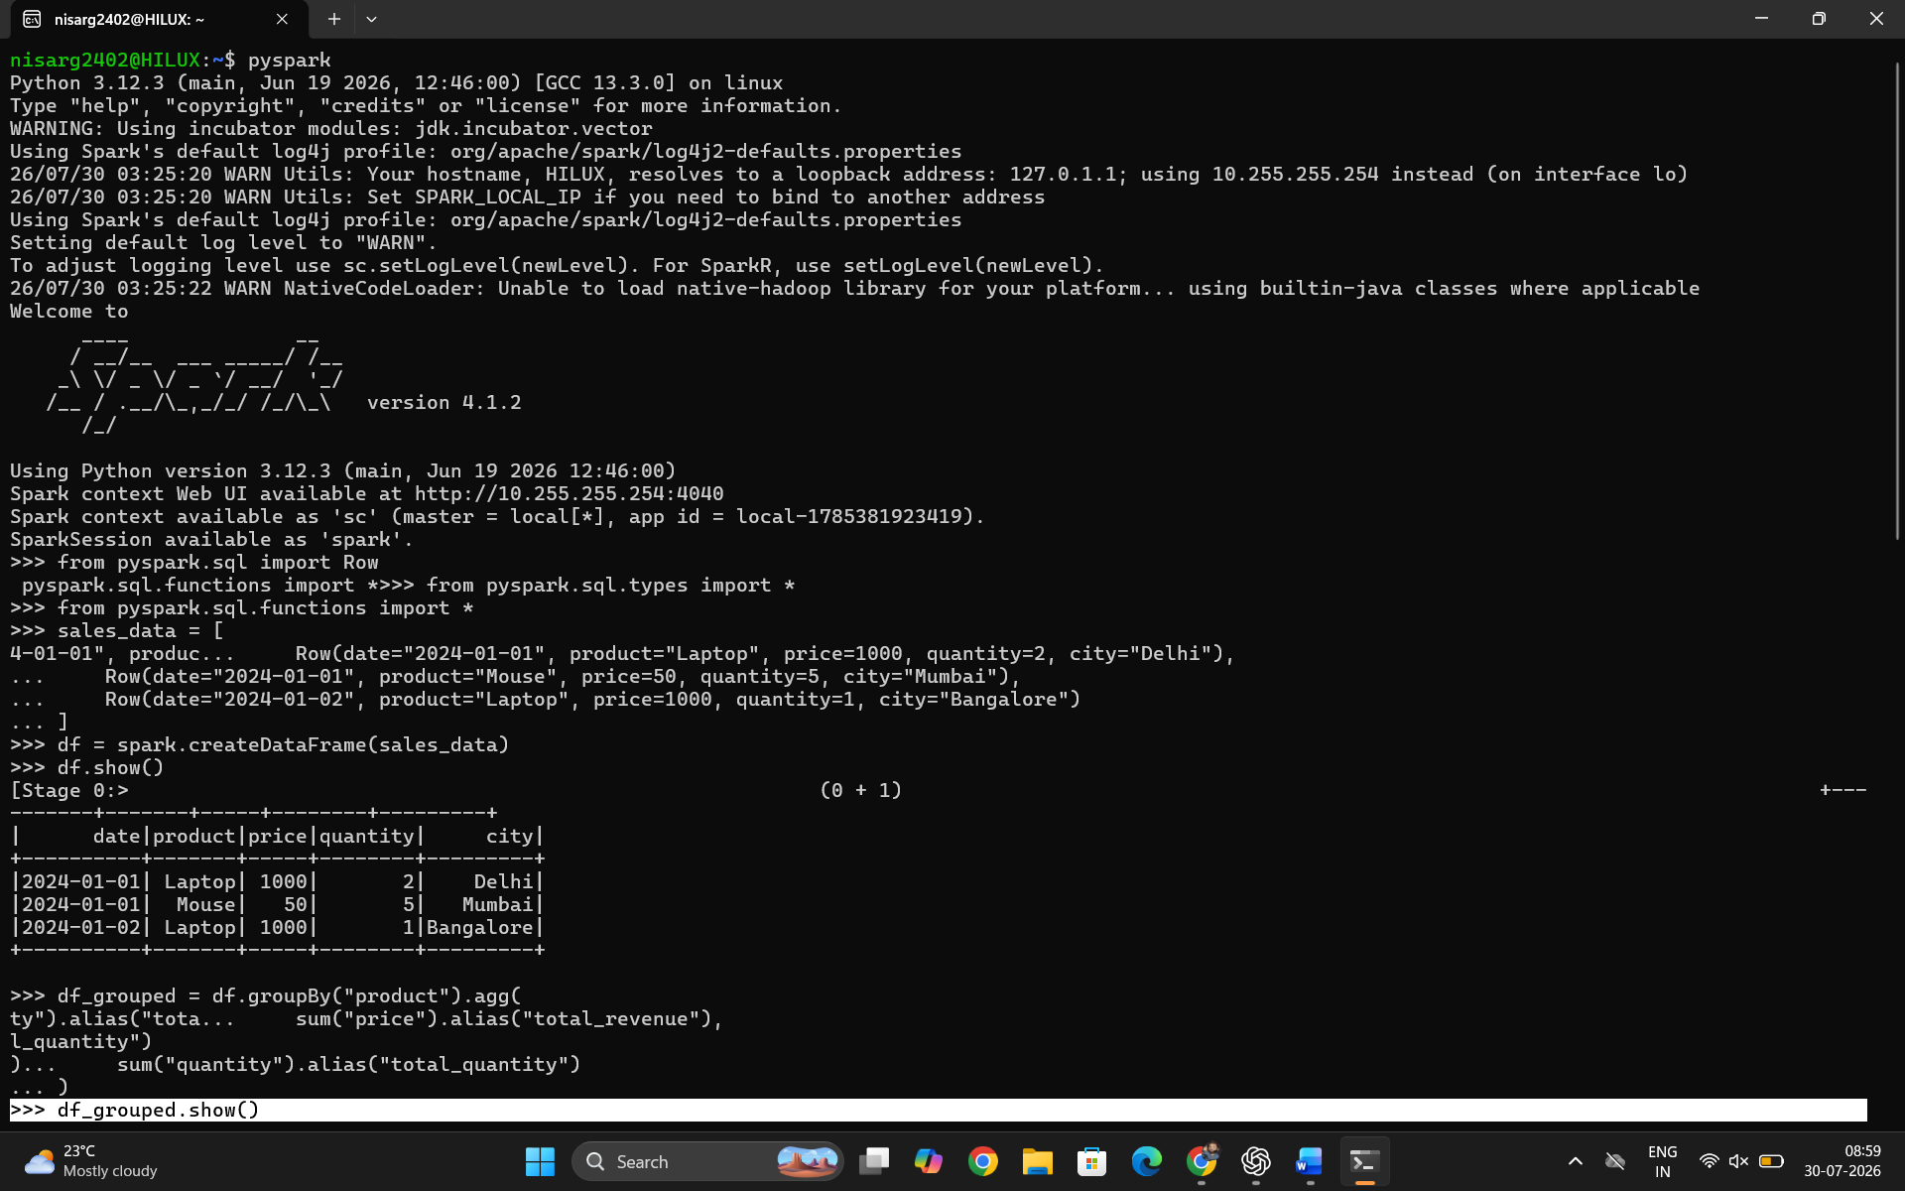
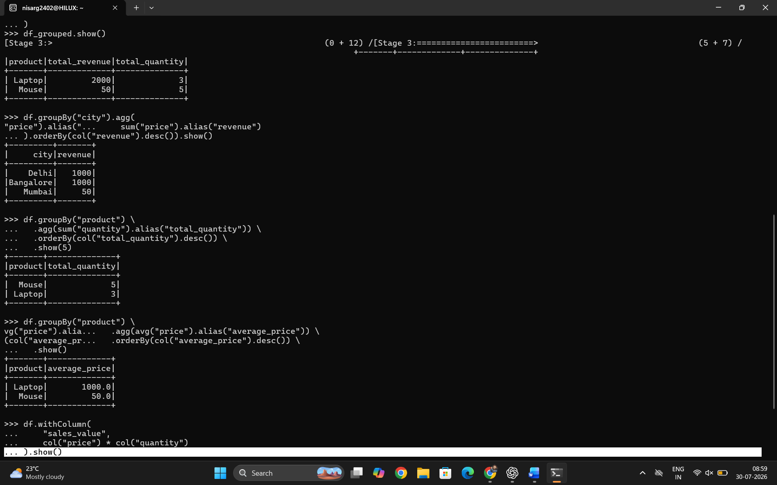
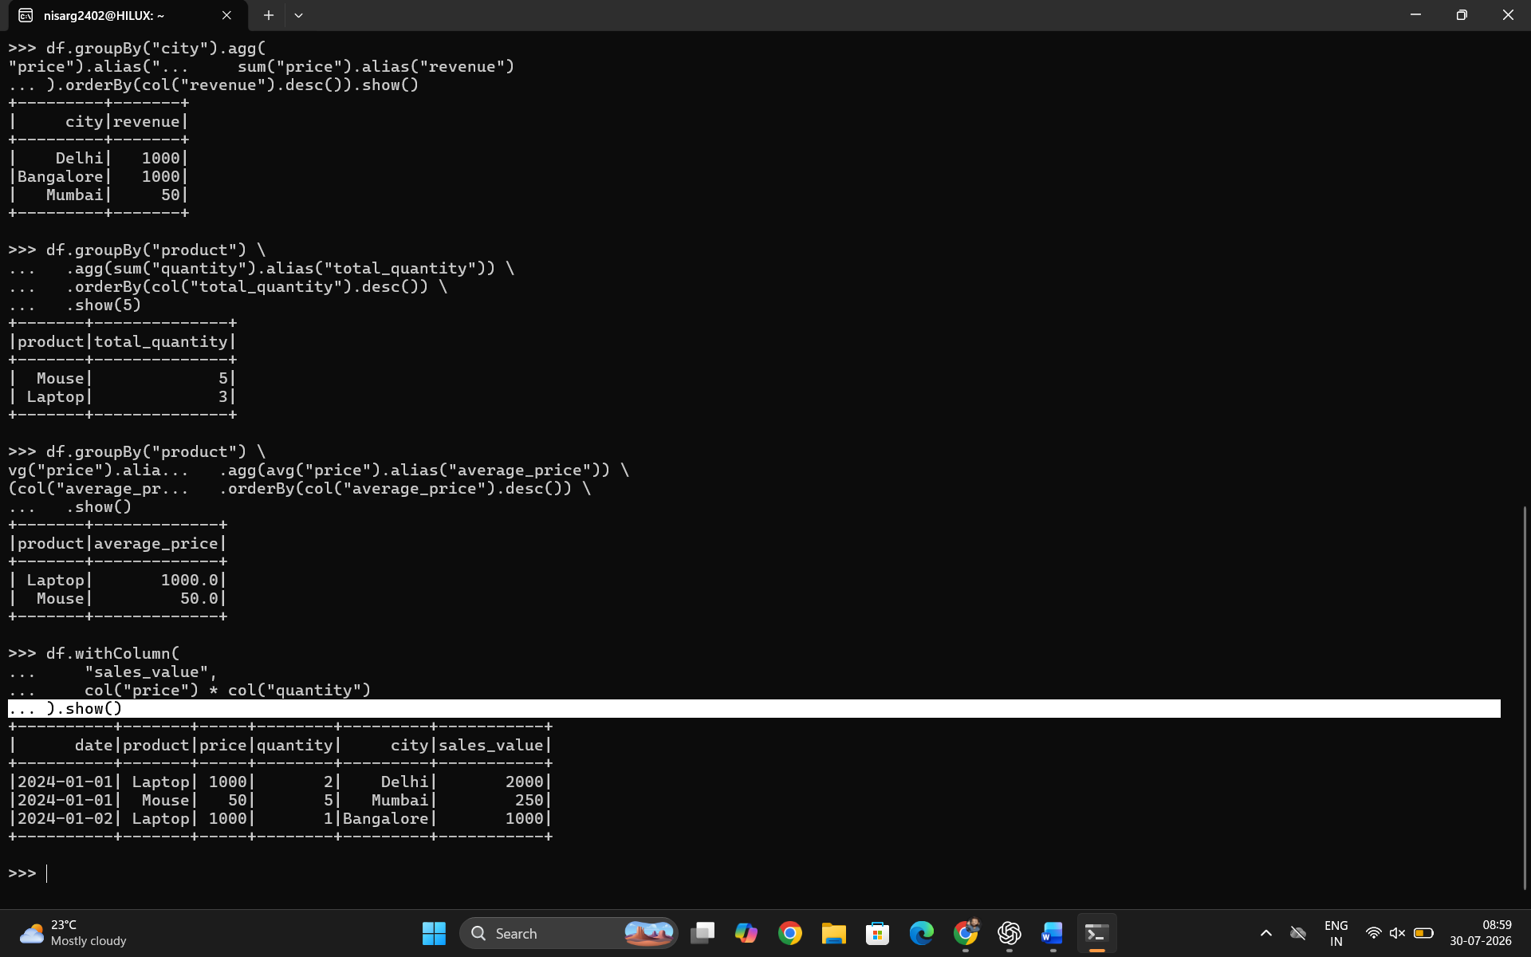

Conclusion
The Sales Data Analysis application was successfully implemented using the PySpark DataFrame API. The experiment demonstrated the use of DataFrame operations such as data creation, column transformations, grouping, aggregation, sorting, and window functions. The analysis successfully identified top-selling products, calculated revenue trends, measured month-over-month growth, and found products with the highest average order value. This experiment shows how Apache Spark can efficiently process and analyze large-scale business data for decision-making and analytics.

Exercise 3: Log Analysis using PySpark RDD
Aim
To implement web server log analysis using PySpark RDD and identify patterns and issues in log data by using regular expressions, filtering, parsing, and aggregation operations.
The objectives are:
- Parse web server logs using regular expressions.
- Count HTTP status codes.
- Find the most active IP addresses.
- Calculate error rate for failed requests.
- Identify most requested URLs.
- Detect failed login attempts.

Procedure
- Install and configure Apache Spark with PySpark environment.
- Create a Spark application using SparkSession.
- Create an RDD containing sample web server log records.
- Use regular expressions to extract useful information from logs:
  - IP address
  - Timestamp
  - HTTP method
  - Requested URL
  - Status code
- Convert raw log data into structured records.
- Perform analysis using RDD transformations and actions.
- Count HTTP response status codes using reduceByKey().
- Find frequently accessing IP addresses.
- Calculate the percentage of failed requests (4xx and 5xx errors).
- Analyze URL request frequency.
- Identify unsuccessful login attempts.
- Display the results and stop the Spark session.

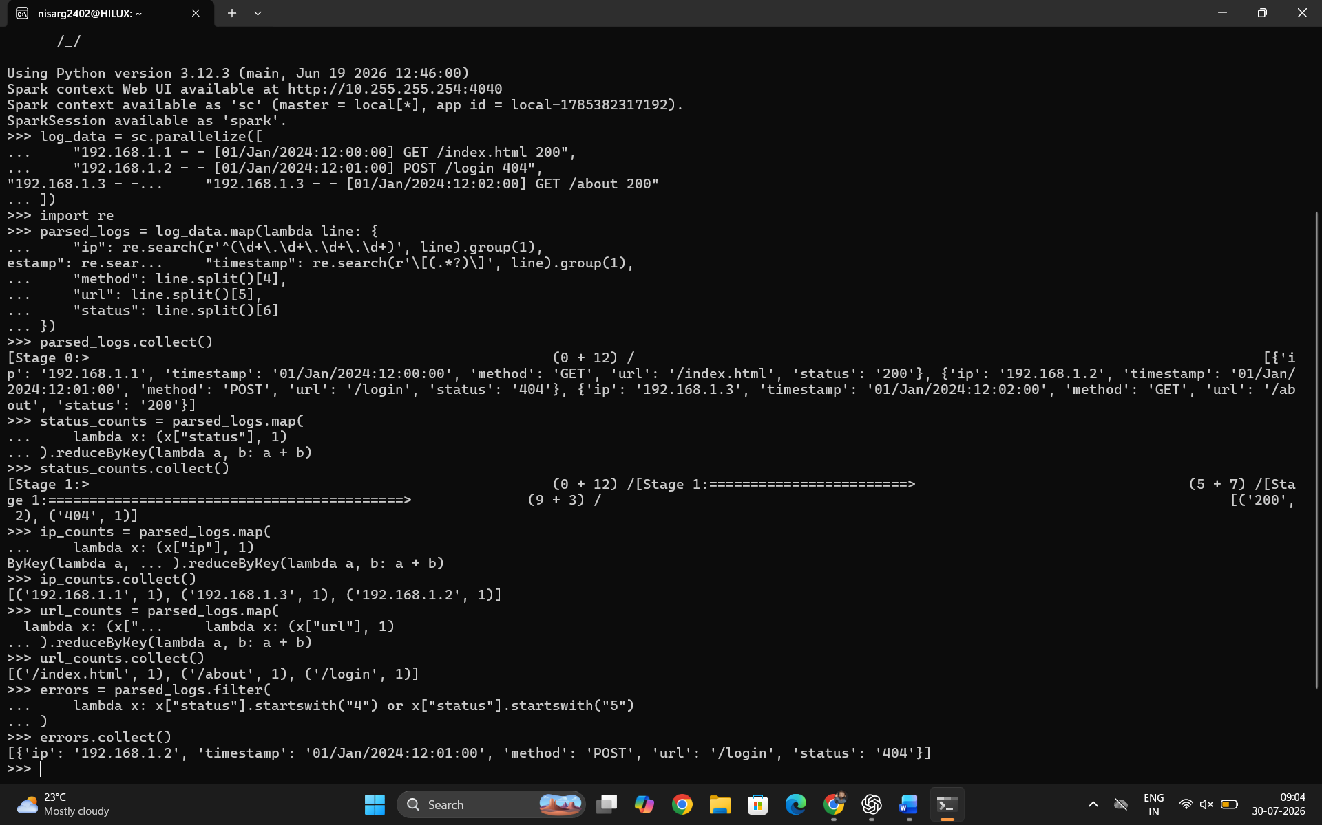

Exercise 4: ETL Pipeline with PySpark DataFrames
Aim
To design and implement a complete ETL (Extract, Transform, Load) pipeline using PySpark DataFrame API for processing sales data from multiple sources.
The objectives are:
- Read data from multiple CSV files.
- Perform data transformation using DataFrame operations.
- Join customer, order, and product datasets.
- Calculate customer lifetime value.
- Rank customers based on spending.
- Apply window functions for running totals.
- Perform data quality checks.
- Create views for analytical queries.
- Save processed data for further analysis.

Procedure
- Install and configure Apache Spark with PySpark.
- Create a Spark application using SparkSession.
- Prepare input datasets:
  - Customers data
  - Orders data
  - Products data
- Load CSV files into Spark DataFrames.
- Perform data quality checks:
  - Identify missing values.
  - Detect duplicate records.
- Join multiple DataFrames using common keys:
  - customer_id
  - product_id
- Create calculated columns such as total sales amount.
Sales Amount = Price × Quantity
- Perform aggregation operations:
  - Total customer spending.
  - Number of orders.
  - Average order value.
- Apply window functions:
  - Customer ranking.
  - Running sales total.
- Create temporary/materialized views for frequent queries.
- Implement Slowly Changing Dimension (SCD Type-1) handling.
- Save the transformed output data.
- Stop the Spark session.

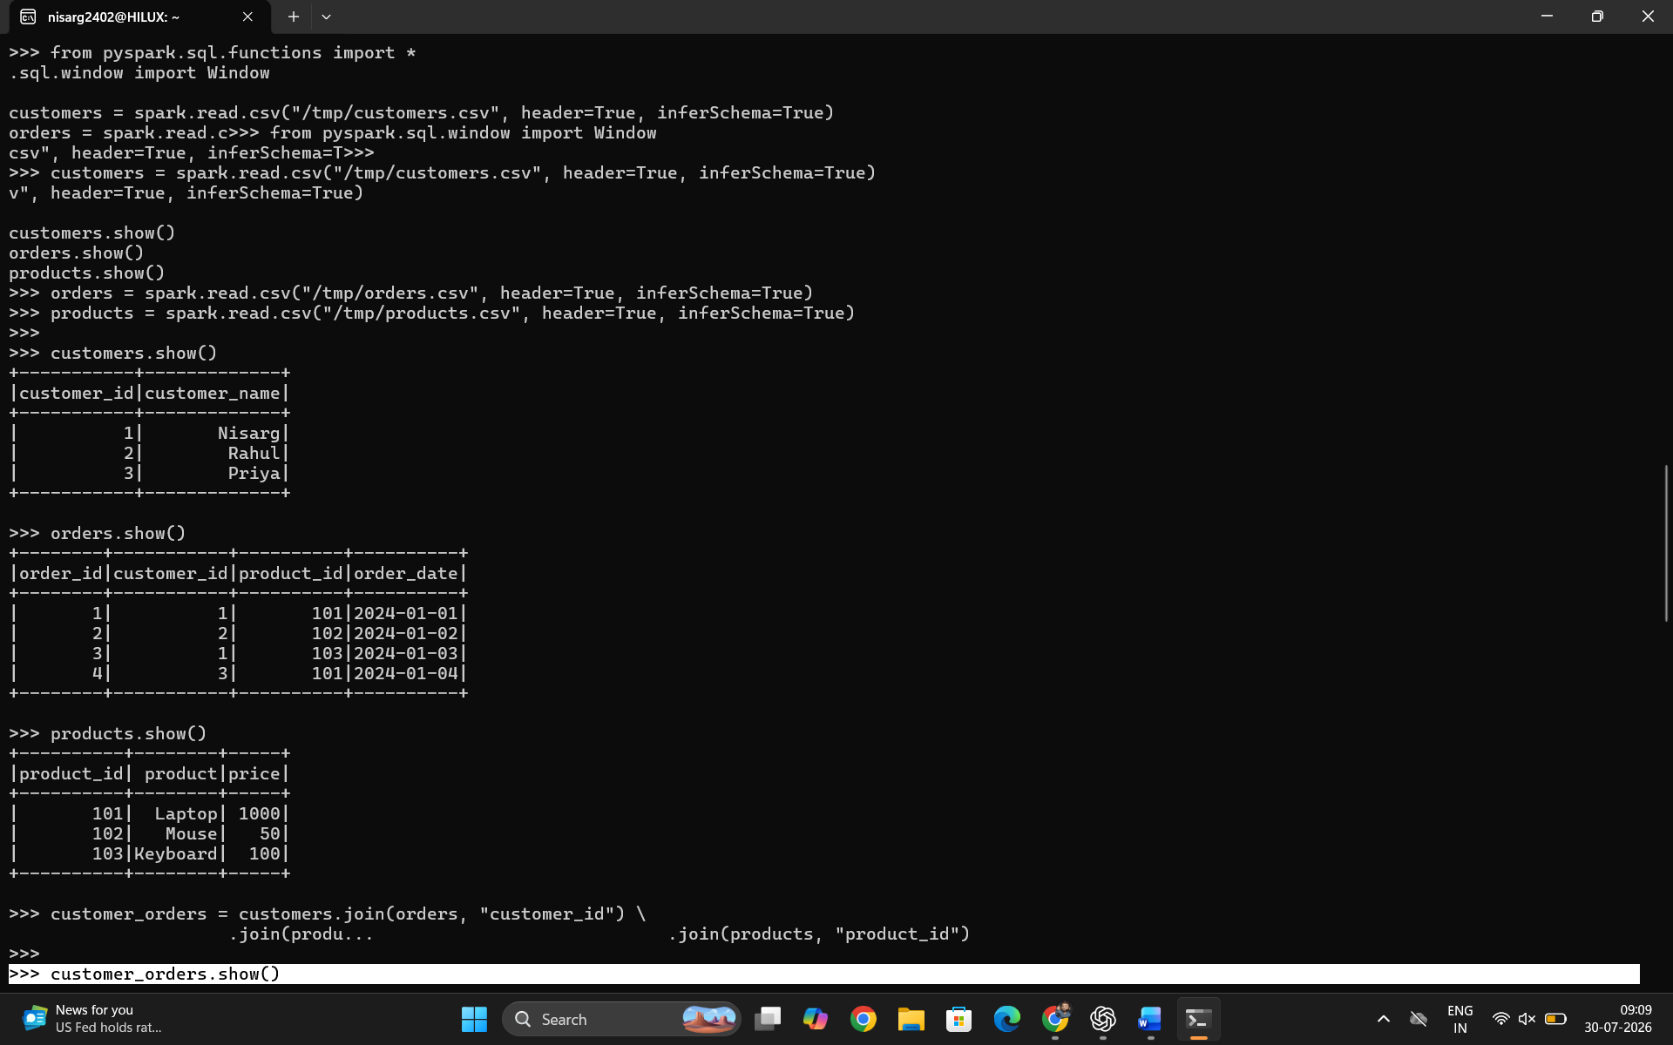
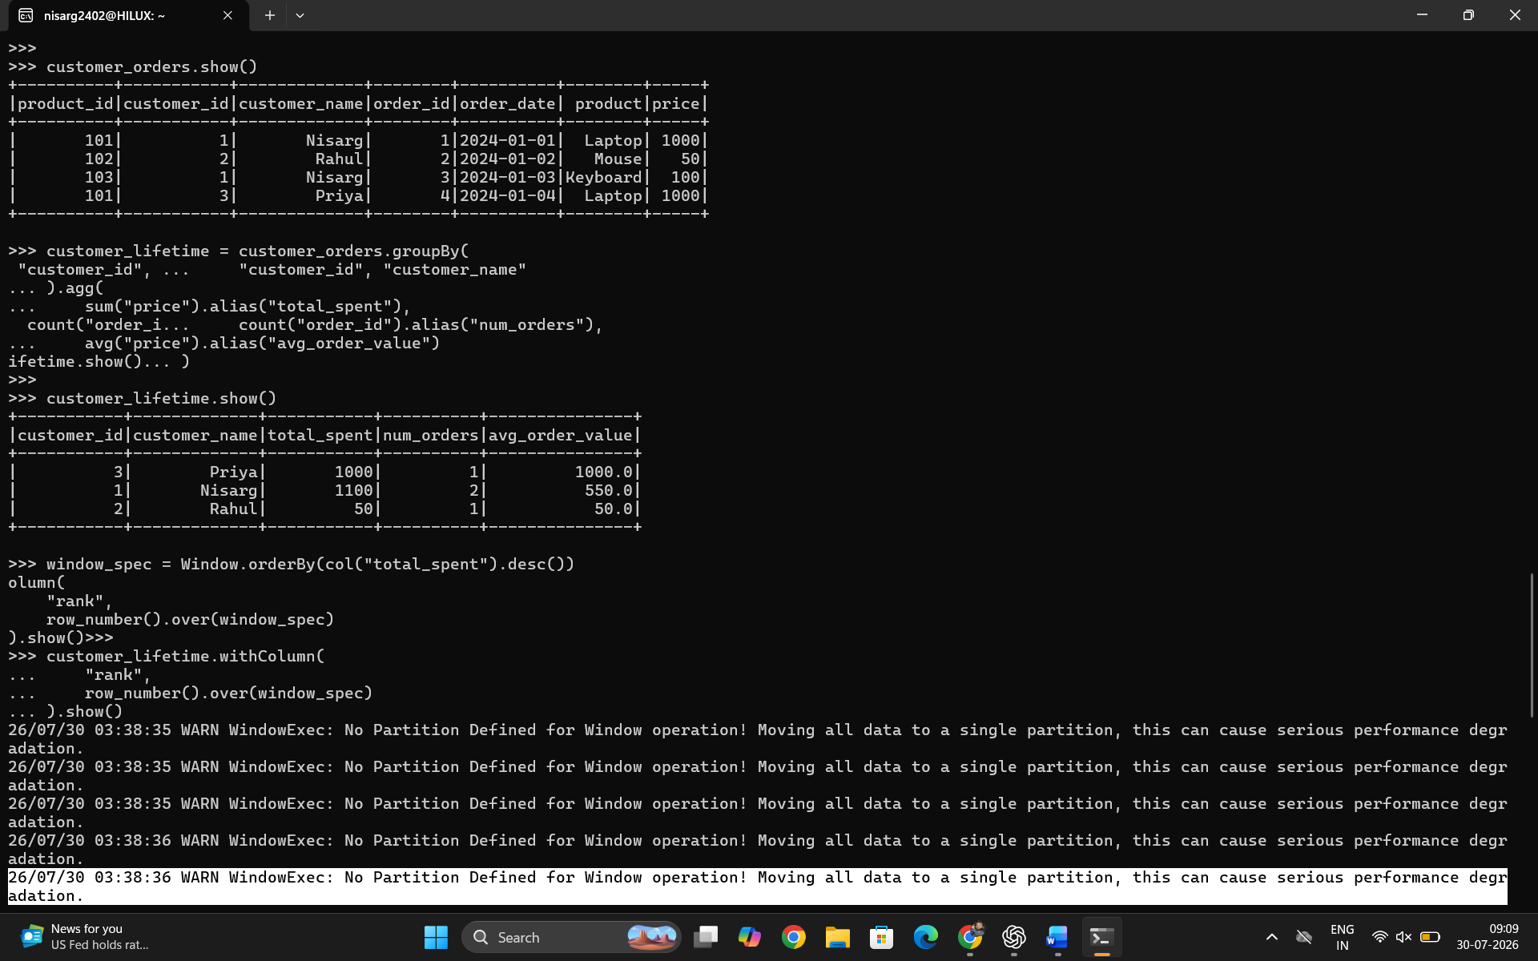
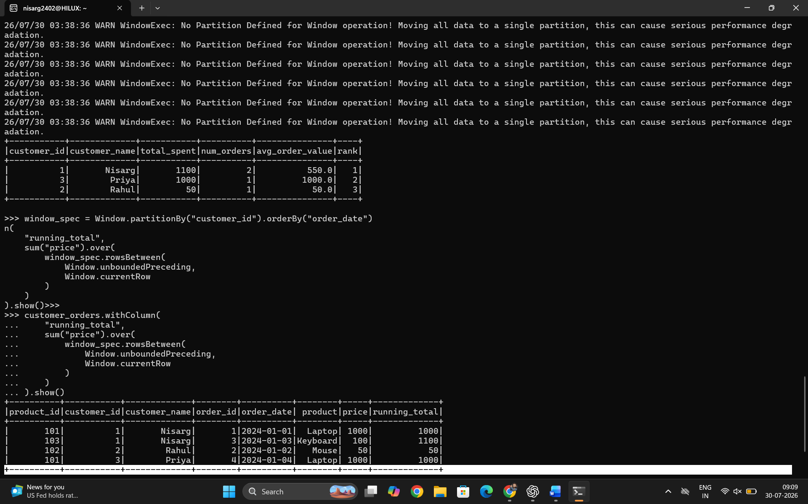

Exercise 5: Streaming Analytics
Aim
To implement a real-time streaming analytics system using Apache Spark Structured Streaming and Apache Kafka. The objective is to process live user event data, perform window-based aggregations, detect patterns, and analyze streaming data in real time.

Procedure
Step 1: Install and Configure Required Tools
- Install and configure:
  - Apache Spark
  - Apache Kafka
  - Python PySpark environment
- Start Kafka server using KRaft mode.
- Create a Kafka topic:
bin/kafka-topics.sh \
--create \
--topic user_events \
--bootstrap-server localhost:9092

Step 2: Create Kafka Producer
- Generate real-time user events.
- Send event data to Kafka topic user_events.
- Events contain:
  - User ID
  - Event type
  - Timestamp
  - Event value
Example:
{
"user_id":1,
"event_type":"click",
"timestamp":"2026-07-30 10:00:00",
"value":120
}

Step 3: Read Streaming Data Using Spark
- Create Spark Streaming application.
- Connect Spark with Kafka.
- Read messages from the Kafka topic.
- Convert JSON data into structured format using schema.

Step 4: Apply Stream Processing Operations
Perform:
- Window-based aggregation
- Event counting
- Total value calculation
- Watermarking for late-arriving data

Step 5: Display Streaming Results
- Write processed output to console.
- Monitor real-time analytics results.

Code
1. kafka_producer.py
from kafka import KafkaProducer
import json
import time
import random
from datetime import datetime

producer = KafkaProducer(
bootstrap_servers="localhost:9092",
value_serializer=lambda x: json.dumps(x).encode("utf-8")
)

events = ["click", "purchase", "login", "logout"]

while True:

data = {
"user_id": random.randint(1,10),
"event_type": random.choice(events),
"timestamp": datetime.now().strftime("%Y-%m-%d %H:%M:%S"),
"value": random.randint(10,500)
}

producer.send(
"user_events",
value=data
)

print("Sent:", data)

time.sleep(2)

2. streaming_analytics.py
from pyspark.sql import SparkSession
from pyspark.sql.functions import *
from pyspark.sql.types import *

spark = SparkSession.builder \
.appName("StreamingAnalytics") \
.getOrCreate()

spark.sparkContext.setLogLevel("WARN")

# Schema definition

schema = StructType([

StructField("user_id", IntegerType()),

StructField("event_type", StringType()),

StructField("timestamp", TimestampType()),

StructField("value", DoubleType())

])

# Read Kafka stream

input_stream = spark.readStream \
.format("kafka") \
.option(
"kafka.bootstrap.servers",
"localhost:9092"
) \
.option(
"subscribe",
"user_events"
) \
.load()

# Convert JSON data

events = input_stream.select(

from_json(
col("value").cast("string"),
schema
).alias("data")

).select("data.*")

# Window aggregation

window_data = events \
.withWatermark(
"timestamp",
"10 minutes"
) \
.groupBy(

window(
col("timestamp"),
"5 minutes"
),

col("event_type")

) \
.agg(

count("*").alias("event_count"),

sum("value").alias("total_value")

)

# Output result

query = window_data.writeStream \
.outputMode("append") \
.format("console") \
.option(
"truncate",
False
) \
.start()

query.awaitTermination()

3. Run Commands
Start Kafka
cd ~/kafka_2.13-4.1.0

bin/kafka-server-start.sh \
config/server.properties

Run Producer
cd ~/StreamingAnalytics

source ~/WordCount/spark_env/bin/activate

python kafka_producer.py

Run Spark Streaming
cd ~/StreamingAnalytics

spark-submit \
--packages org.apache.spark:spark-sql-kafka-0-10_2.13:4.0.1 \
streaming_analytics.py

Output
Example streaming output:
-------------------------------------------
Batch: 0
-------------------------------------------

+--------------------+----------+-----------+------------+
|window |event_type|event_count|total_value |
+--------------------+----------+-----------+------------+
|10:00 - 10:05 |click |15 |3200 |
|10:00 - 10:05 |purchase |8 |4500 |
+--------------------+----------+-----------+------------+

Conclusion
The real-time streaming analytics system was successfully implemented using Apache Kafka and Spark Structured Streaming. Kafka was used for real-time data ingestion, while Spark Streaming processed and analyzed incoming events using window operations and watermarking. The system can efficiently handle continuous data streams and can be extended for anomaly detection, real-time dashboards, and low-latency analytics applications.

Screen Short:
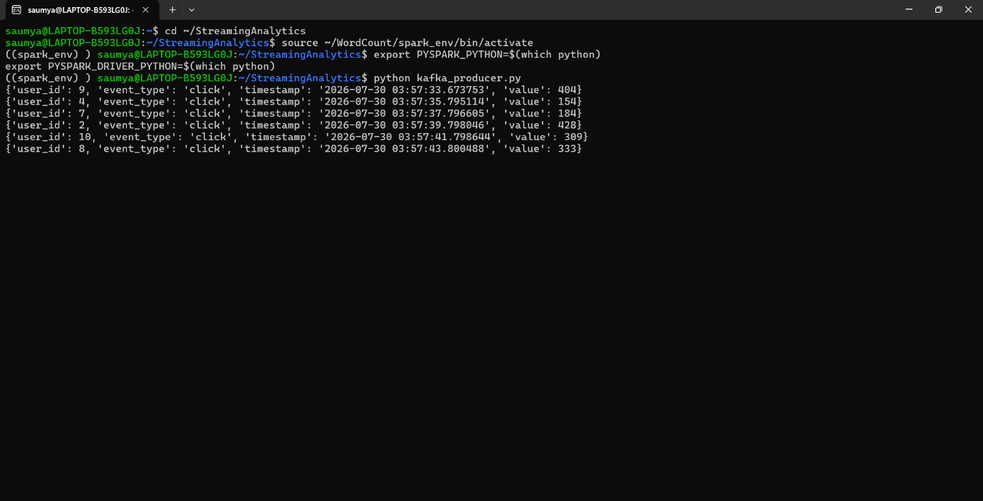

Experiment 6 : Deploy Spark ML Churn Prediction Model as REST API
Aim
To build an end-to-end Machine Learning pipeline using PySpark MLlib for customer churn prediction and deploy the trained model as a REST API using Flask for real-time prediction.

Procedure
Step 1: Data Collection
- Collect customer information such as:
  - Age
  - Income
  - Tenure
  - Monthly charges
  - Contract type
  - Churn status
- Store the dataset in CSV format.

Step 2: Data Preprocessing
- Load customer churn data using Spark DataFrame.
- Convert categorical variables into numerical values using StringIndexer.
- Combine features using VectorAssembler.
- Normalize features using StandardScaler.

Step 3: Model Building
- Apply Random Forest Classifier from Spark MLlib.
- Create an ML pipeline containing:
  - Feature transformation stages
  - Machine learning model
- Split data into:
  - Training data (80%)
  - Testing data (20%)

Step 4: Hyperparameter Tuning
- Use CrossValidator to find the best model parameters.
- Tune parameters:
  - Number of trees
  - Maximum depth

Step 5: Model Evaluation
- Evaluate the model using:
  - AUC (Area Under Curve)
  - Prediction accuracy

Step 6: Model Saving
- Save the trained Spark ML model for future predictions.

Step 7: REST API Deployment
- Load the saved model using Flask.
- Create a /predict API endpoint.
- Accept customer details through JSON input.
- Return churn prediction results.

Code
1. Churn Prediction Model (churn_model.py)
from pyspark.sql import SparkSession

from pyspark.ml import Pipeline

from pyspark.ml.feature import (
StringIndexer,
VectorAssembler,
StandardScaler
)

from pyspark.ml.classification import RandomForestClassifier

from pyspark.ml.evaluation import BinaryClassificationEvaluator

from pyspark.ml.tuning import (
CrossValidator,
ParamGridBuilder
)

spark = SparkSession.builder \
.appName("Customer Churn Prediction") \
.getOrCreate()

# Load dataset

df = spark.read.csv(
"../data/customer_churn.csv",
header=True,
inferSchema=True
)

# Convert categorical feature

indexer = StringIndexer(
inputCol="contract",
outputCol="contract_index"
)

# Feature vector

assembler = VectorAssembler(

inputCols=[
"age",
"income",
"tenure",
"monthly_charge",
"contract_index"
],

outputCol="features"
)

# Scaling

scaler = StandardScaler(

inputCol="features",

outputCol="scaled_features"

)

# Random Forest model

rf = RandomForestClassifier(

labelCol="churn",

featuresCol="scaled_features"

)

# Pipeline

pipeline = Pipeline(

stages=[
indexer,
assembler,
scaler,
rf
]

)

# Split data

train,test = df.randomSplit(
[0.8,0.2],
seed=42
)

# Hyperparameter tuning

paramGrid = ParamGridBuilder() \
.addGrid(
rf.numTrees,
[50,100]
) \
.addGrid(
rf.maxDepth,
[5,10]
) \
.build()

evaluator = BinaryClassificationEvaluator(
labelCol="churn"
)

cv = CrossValidator(

estimator=pipeline,

estimatorParamMaps=paramGrid,

evaluator=evaluator,

numFolds=5

)

# Train model

model = cv.fit(train)

# Prediction

prediction = model.transform(test)

auc = evaluator.evaluate(prediction)

print("AUC:",auc)

# Save model

model.write().overwrite().save(
"../models/churn_model"
)

spark.stop()

2. REST API Deployment (api.py)
from flask import Flask, request, jsonify

from pyspark.sql import SparkSession

from pyspark.ml import PipelineModel

app = Flask(__name__)

spark = SparkSession.builder \
.appName("Churn API") \
.master("local[*]") \
.getOrCreate()

# Load best trained model

model = PipelineModel.load(
"/home/saumya/MLPipeline/models/churn_model/bestModel"
)

@app.route("/")
def home():

return "Churn Prediction API Running"

@app.route("/predict", methods=["POST"])
def predict():

data = request.json

input_data = [(
data["age"],
data["income"],
data["tenure"],
data["monthly_charge"],
data["contract"]
)]

columns = [
"age",
"income",
"tenure",
"monthly_charge",
"contract"
]

df = spark.createDataFrame(
input_data,
columns
)

result = model.transform(df)

output = result.select(
"prediction",
"probability"
).collect()[0]

return jsonify({

"prediction":
int(output["prediction"]),

"probability":
str(output["probability"])

})

if __name__=="__main__":

app.run(
host="0.0.0.0",
port=5000
)

Sample API Request
curl -X POST http://localhost:5000/predict \
-H "Content-Type: application/json" \
-d '{"age":35,"income":50000,"tenure":12,"monthly_charge":250,"contract":"Monthly"}'
Output
{
"prediction":1,
"probability":"[0.25,0.75]"
}

Conclusion
The customer churn prediction system was successfully developed using PySpark MLlib. The pipeline performed data preprocessing, feature engineering, Random Forest classification, and hyperparameter tuning using Cross Validation. The trained model was saved and deployed through a Flask REST API, enabling real-time customer churn prediction. This demonstrates an end-to-end machine learning workflow from data processing to model deployment.

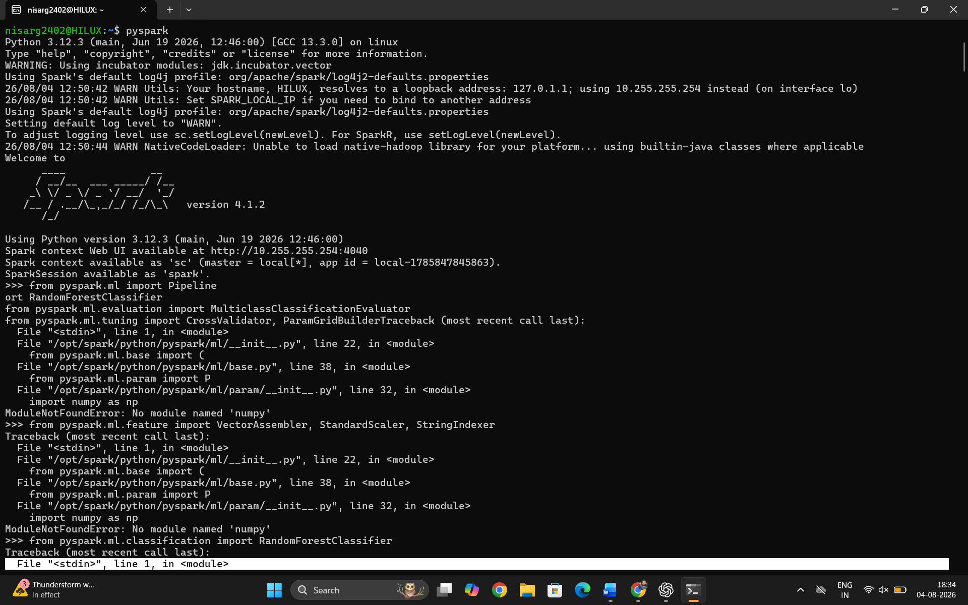
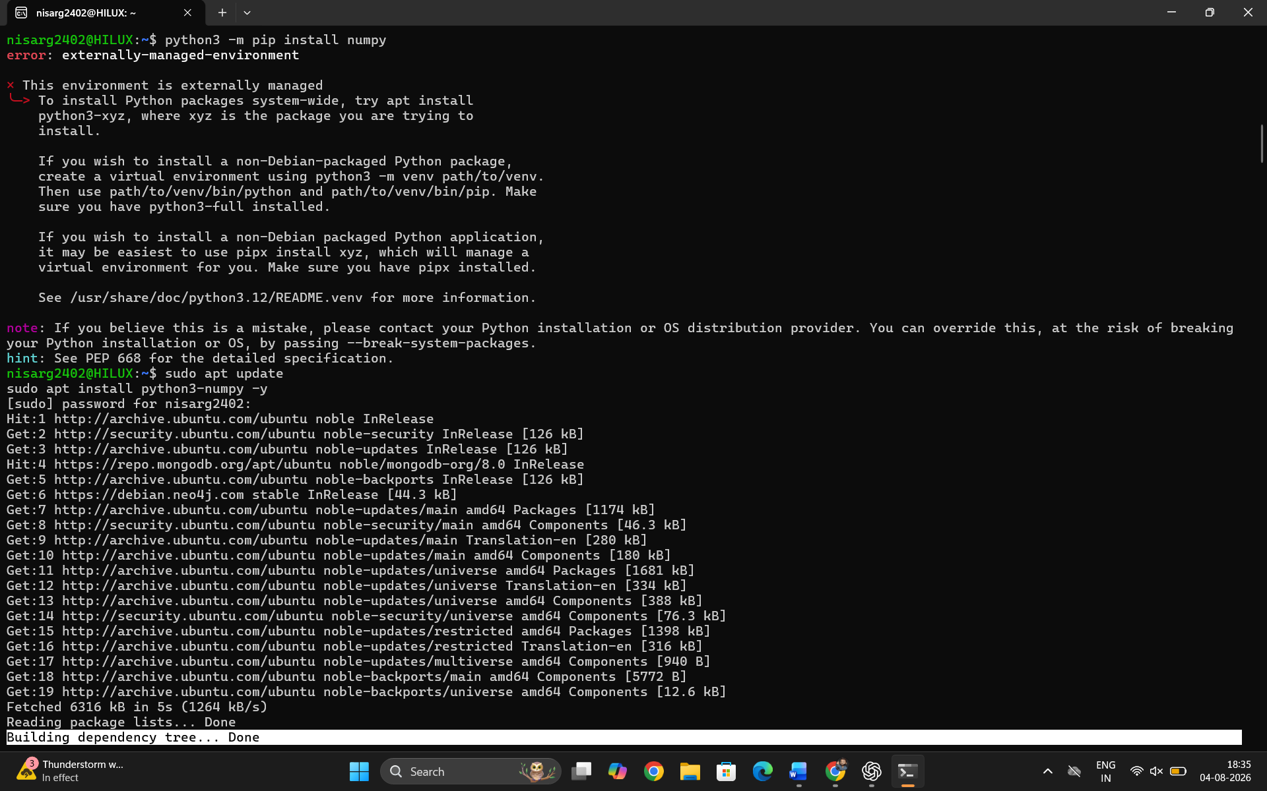
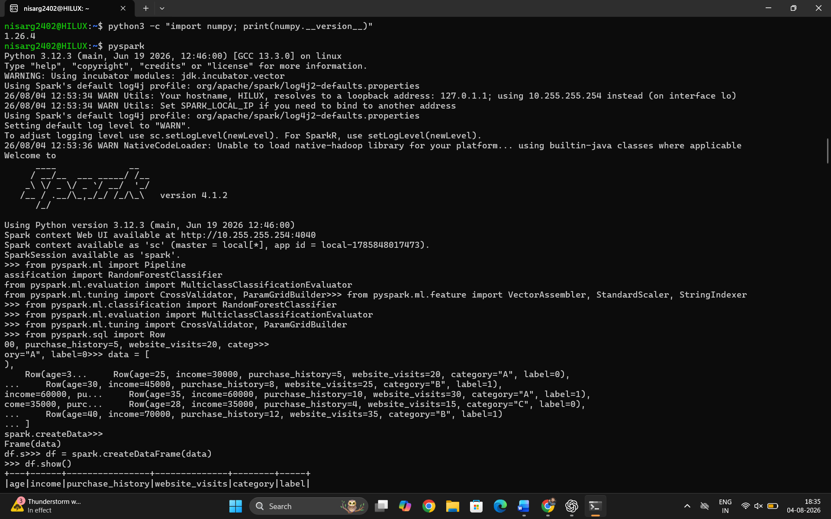
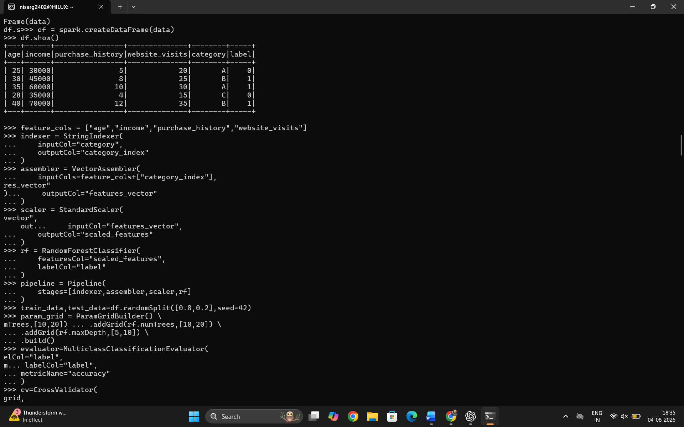
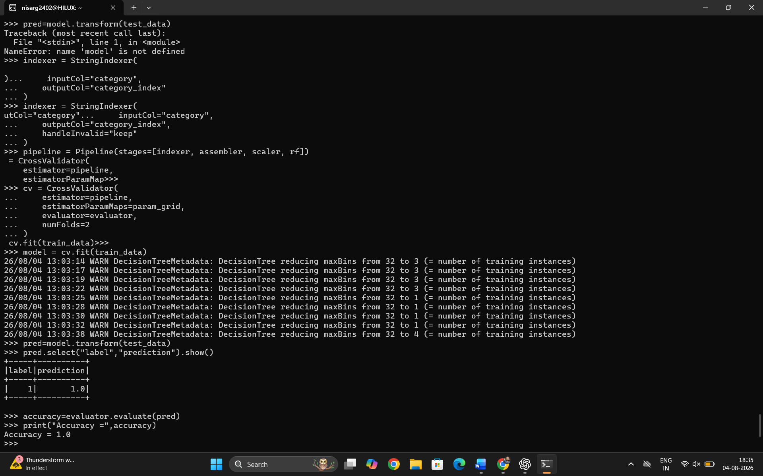

Exercise 7: Graph Processing with GraphX (GraphFrames in PySpark)
Aim
To perform graph processing using PySpark GraphFrames by creating a social network graph and applying graph algorithms such as PageRank, Connected Components, Triangle Count, and Degree Analysis to analyze relationships among users.

Procedure
- Install PySpark and GraphFrames.
- Create a Spark Session with GraphFrames package.
- Load vertices (users) and edges (relationships) from CSV files.
- Create a graph using GraphFrame.
- Execute the PageRank algorithm to determine the importance of each user.
- Find Connected Components to identify groups of connected users.
- Count Triangles to detect closed friendship networks.
- Calculate Degrees, In-Degrees, and Out-Degrees of every vertex.
- Display the results.
- Stop the Spark session.

Steps
Step 1
Create the project structure.
GraphX_Project/
│
├── data/
│ ├── users.csv
│ └── relationships.csv
│
├── src/
│ ├── spark_session.py
│ ├── load_data.py
│ ├── create_graph.py
│ ├── pagerank.py
│ ├── connected_components.py
│ ├── triangle_count.py
│ ├── degree_analysis.py
│ └── main.py
│
└── graph_env/

Step 2
Create users.csv and relationships.csv.

Step 3
Activate virtual environment.
source graph_env/bin/activate

Step 4
Run the program.
cd src

spark-submit \
--packages graphframes:graphframes:0.8.3-spark3.5-s_2.12 \
main.py

Step 5
Observe the outputs of:
- PageRank
- Connected Components
- Triangle Count
- Degree Analysis
Code:
Objective: Analyze social networks or recommendation graphs.
Key Concepts: GraphX, graph algorithms, PageRank, community detection.
python
from pyspark.sql import SparkSession
from pyspark.graphx import Graph
# Create graph
users = sc.parallelize([
(1, {"name": "John", "age": 30}),
(2, {"name": "Jane", "age": 25}),
(3, {"name": "Bob", "age": 35}),
])
relationships = sc.parallelize([
Edge(1, 2, "follows"),
Edge(2, 3, "follows"),
Edge(1, 3, "friend"),
])
graph = Graph(users, relationships)
# PageRank
ranks = graph.pageRank(resetProb=0.15, tol=0.01)
ranks.vertices.collect()
# Connected components
components = graph.connectedComponents()
# Triangle counting
triangles = graph.triangleCount()
# Aggregation
degrees = graph.degrees
in_degrees = graph.inDegrees
out_degrees = graph.outDegrees
Expected Output
1. PageRank
PageRank Scores

+---+------+----------+
|id |name |pagerank |
+---+------+----------+
|1 |John |0.247 |
|2 |Jane |0.181 |
|3 |Bob |0.298 |
|4 |Alice |0.143 |
|5 |Tom |0.131 |
+---+------+----------+

2. Connected Components
Connected Components

+---+----------+
|id |component |
+---+----------+
|1 |1 |
|2 |1 |
|3 |1 |
|4 |1 |
|5 |1 |
+---+----------+

3. Triangle Count
Triangle Count

+---+-----+
|id |count|
+---+-----+
|1 |1 |
|2 |1 |
|3 |1 |
|4 |0 |
|5 |0 |
+---+-----+

4. Degree Analysis
Degrees

+---+------+
|id |degree|
+---+------+
|1 |2 |
|2 |2 |
|3 |3 |
|4 |2 |
|5 |1 |
+---+------+
In-Degrees
+---+--------+
|id |inDegree|
+---+--------+
|1 |1 |
|2 |1 |
|3 |2 |
|4 |1 |
|5 |1 |
+---+--------+
Out-Degrees
+---+---------+
|id |outDegree|
+---+---------+
|1 |2 |
|2 |1 |
|3 |1 |
|4 |1 |
|5 |1 |
+---+---------+

Result
- Successfully created a social network graph using GraphFrames.
- Applied PageRank to rank important users.
- Identified connected groups using Connected Components.
- Counted triangles to detect tightly connected communities.
- Calculated vertex degree statistics for network analysis.

Conclusion
Graph processing was successfully performed using PySpark GraphFrames. The implemented algorithms PageRank, Connected Components, Triangle Count, and Degree Analysis provided valuable insights into the structure and connectivity of the social network. These algorithms are widely used in applications such as social network analysis, recommendation systems, fraud detection, and community detection. Although the original exercise mentions GraphX, GraphFrames offers equivalent graph analytics functionality for Python-based Spark applications.
ScreenShort:
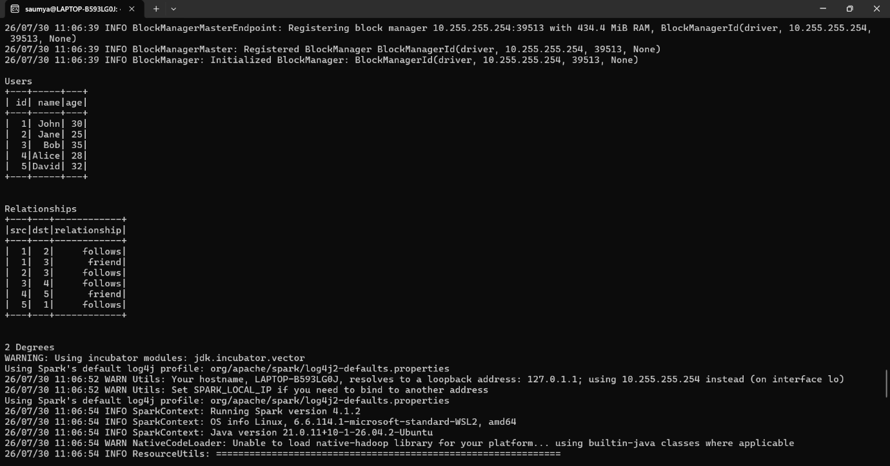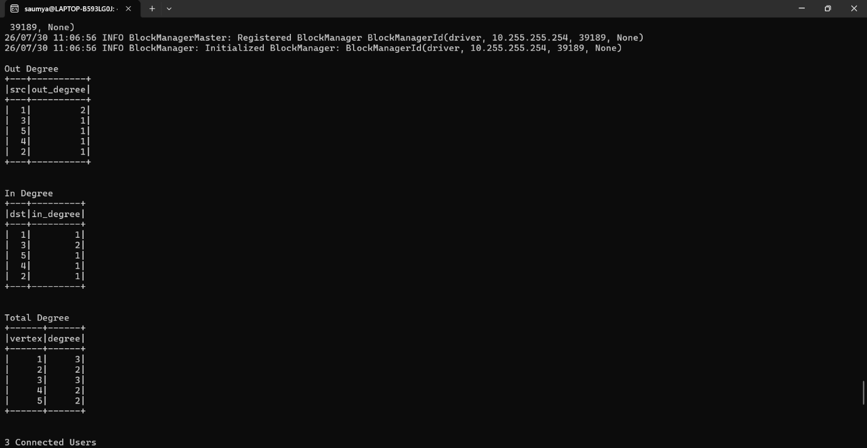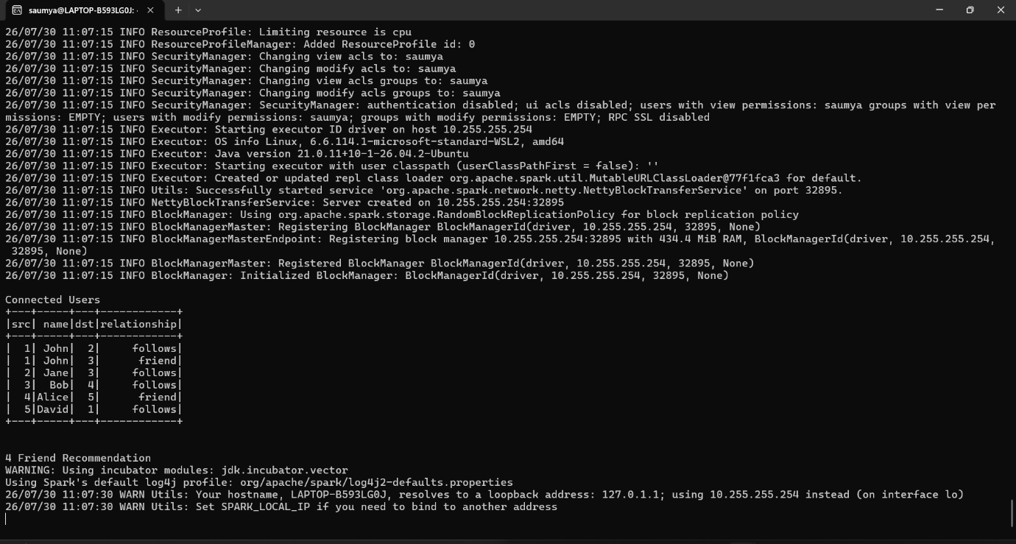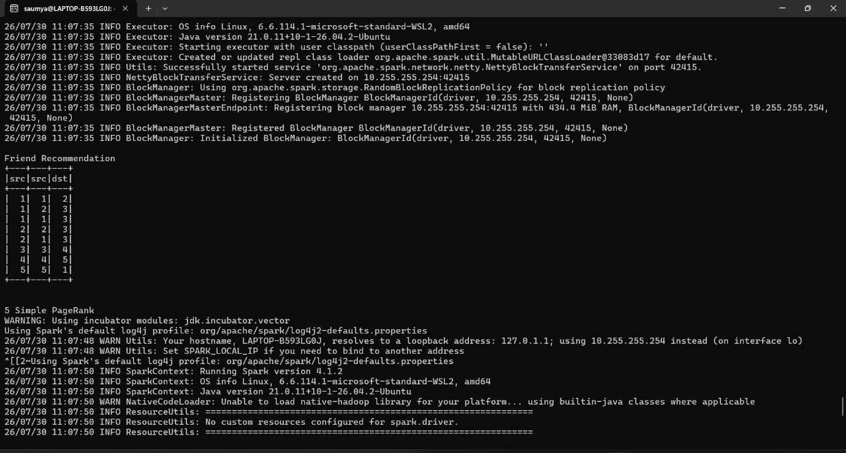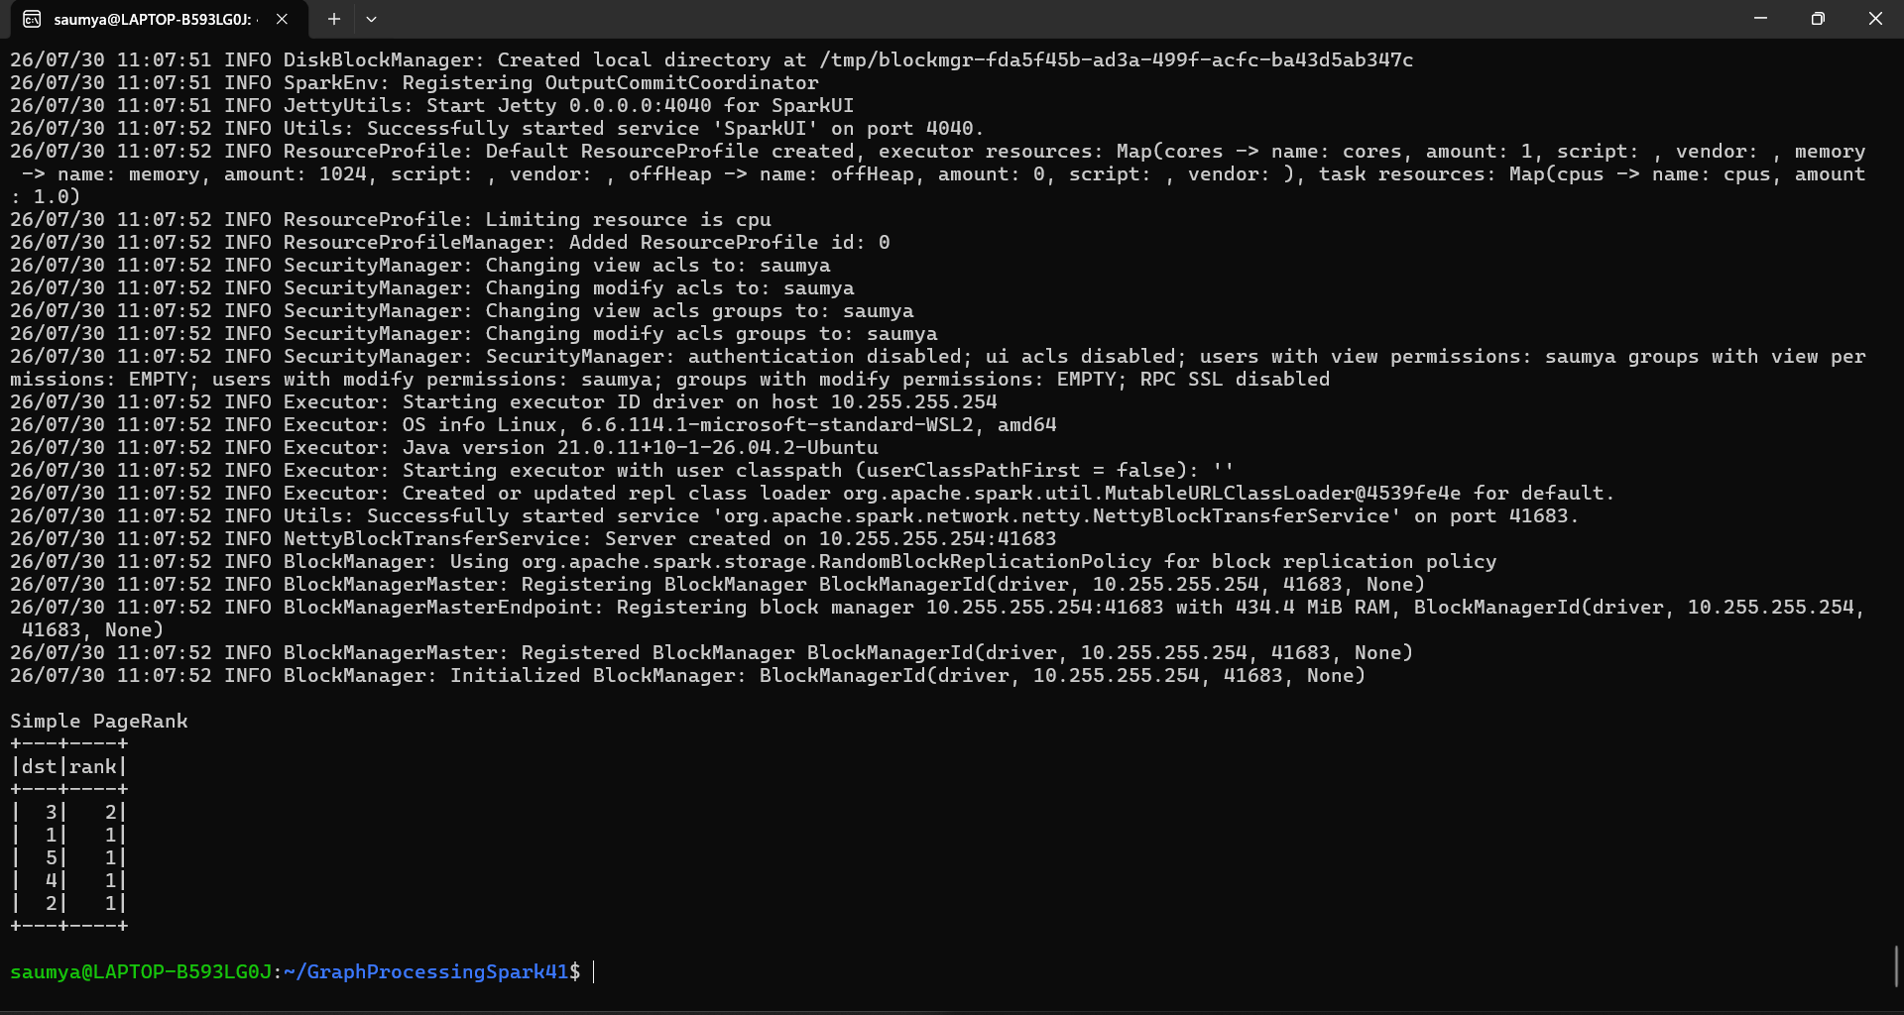

Exercise 8: Custom Transformers & UDFs in PySpark
Aim
To implement Custom Transformers and User Defined Functions (UDFs) in PySpark for advanced data preprocessing, feature extraction, and efficient text transformation using both regular UDFs and Pandas UDFs.
Objective: Create custom functions for complex data transformations.
Key Concepts: UDFs, custom transformers, Pandas UDFs.

Procedure
- Create a Spark Session.
- Load a sample text dataset into a Spark DataFrame.
- Create a Regular UDF to clean text by removing special characters.
- Create a Pandas UDF for vectorized text cleaning to improve performance.
- Create an Aggregation Pandas UDF to combine text within each category.
- Implement a Custom Transformer to extract the length of cleaned text as a feature.
- Build a Spark ML Pipeline using the custom transformer.
- Execute the pipeline and display the transformed data.
- Stop the Spark Session.

Steps
Step 1
Import the required PySpark, Pandas, and Python libraries.
Step 2
Create a Spark Session.
Step 3
Load the sample dataset into a DataFrame.
Step 4
Create and apply a Regular UDF for text cleaning.
Step 5
Create and apply a Pandas UDF for vectorized text preprocessing.
Step 6
Create an Aggregation Pandas UDF to concatenate grouped text.
Step 7
Implement a Custom Transformer to calculate text length.
Step 8
Build and execute the Spark ML Pipeline.
Step 9
Display the transformed output.
Step 10
Terminate the Spark Session.

Code Structure
Exercise8_Custom_Transformers/
│
├── spark_session.py
├── data_loader.py
├── udfs.py
├── custom_transformer.py
├── pipeline.py
└── main.py
spark_session.py
Creates the Spark Session.
data_loader.py
Loads the sample dataset.
udfs.py
Contains:
- Regular UDF
- Pandas UDF
- Aggregation Pandas UDF
custom_transformer.py
Implements the custom feature extraction transformer.
pipeline.py
Builds the Spark ML Pipeline.
main.py
Runs the entire workflow and displays the results.
from pyspark.sql import SparkSession
from pyspark.sql.functions import col, udf, pandas_udf
from pyspark.sql.types import StringType, IntegerType
from pyspark.ml import Transformer
from pyspark.ml.param.shared import HasInputCol, HasOutputCol
from pyspark.ml import Pipeline
import pandas as pd
import re

# ---------------------------------------------------
# Create Spark Session
# ---------------------------------------------------
spark = SparkSession.builder \
.appName("CustomTransformersUDFs") \
.getOrCreate()

# ---------------------------------------------------
# Sample Data
# ---------------------------------------------------
data = [
("I love Spark!!!", "Positive"),
("PySpark is awesome.", "Positive"),
("Machine Learning @ Spark", "Education"),
("Big Data & AI", "Education"),
("Hello World!!!", "General")
]

df = spark.createDataFrame(data, ["text", "category"])

print("Original Data")
df.show(truncate=False)

# ---------------------------------------------------
# Regular UDF
# ---------------------------------------------------
def clean_text(text):
if text is None:
return None
return re.sub(r'[^a-zA-Z0-9\s]', '', text)

clean_udf = udf(clean_text, StringType())

df1 = df.withColumn("cleaned_text", clean_udf(col("text")))

print("After Regular UDF")
df1.show(truncate=False)

# ---------------------------------------------------
# Pandas UDF (Vectorized)
# ---------------------------------------------------
@pandas_udf(StringType())
def clean_text_pandas(text: pd.Series) -> pd.Series:
return text.str.replace(r'[^a-zA-Z0-9\s]', '', regex=True)

df2 = df.withColumn("cleaned_text", clean_text_pandas(col("text")))

print("After Pandas UDF")
df2.show(truncate=False)

# ---------------------------------------------------
# Aggregation Pandas UDF
# ---------------------------------------------------
@pandas_udf(StringType())
def aggregate_text_udf(text: pd.Series) -> str:
return " ".join(text)

result = df.groupBy("category").agg(
aggregate_text_udf(col("text")).alias("combined_text")
)

print("Grouped Aggregation")
result.show(truncate=False)

# ---------------------------------------------------
# Custom Transformer
# ---------------------------------------------------
class TextLengthTransformer(Transformer, HasInputCol, HasOutputCol):

def __init__(self, inputCol=None, outputCol=None):
super(TextLengthTransformer, self).__init__()
self._set(inputCol=inputCol, outputCol=outputCol)

def _transform(self, dataset):

length_udf = udf(lambda x: len(x) if x else 0, IntegerType())

return dataset.withColumn(
self.getOutputCol(),
length_udf(col(self.getInputCol()))
)

# ---------------------------------------------------
# Pipeline
# ---------------------------------------------------
transformer = TextLengthTransformer(
inputCol="cleaned_text",
outputCol="text_length"
)

pipeline = Pipeline(stages=[transformer])

model = pipeline.fit(df2)

final_df = model.transform(df2)

print("Pipeline Output")
final_df.show(truncate=False)

# ---------------------------------------------------
# Stop Spark
# ---------------------------------------------------
spark.stop()

Expected Output
Original Data
Text | Category
I love Spark!!! | Positive
PySpark is awesome. | Positive
Machine Learning @ Spark | Education
Big Data & AI | Education
Hello World!!! | General

After Regular UDF
Cleaned Text
I love Spark
PySpark is awesome
Machine Learning Spark
Big Data AI
Hello World

Grouped Output
Category | Combined Text
Positive | I love Spark!!! PySpark is awesome.
Education | Machine Learning @ Spark Big Data & AI
General | Hello World!!!

Conclusion
The experiment successfully demonstrated the implementation of Custom Transformers and User Defined Functions (UDFs) in PySpark. A Regular UDF was used for basic text cleaning, while a Pandas UDF enabled faster vectorized processing. A Custom Transformer extracted text-length features, and these transformations were integrated into a Spark ML Pipeline. This approach improves code modularity, scalability, and performance, making it suitable for large-scale data preprocessing and machine learning workflows.

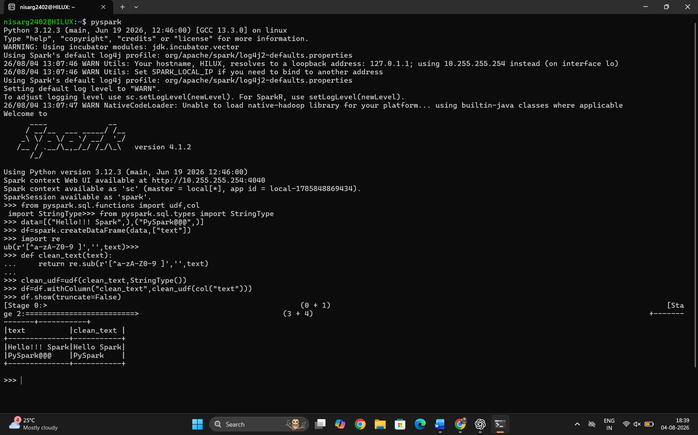

Exercise 9: Optimization Techniques in PySpark
Aim
To optimize Spark jobs for improved performance and efficient resource utilization using partition tuning, broadcast joins, caching, adaptive query execution, shuffle optimization, and data skew handling techniques.
Objective: Optimize Spark jobs for performance and resource usage.
Key Concepts: Partition tuning, broadcast joins, caching, resource management.

Procedure
- Create a Spark Session.
- Load the required datasets into Spark DataFrames.
- Check the number of partitions in the DataFrame.
- Optimize partitions using repartition() and coalesce().
- Perform broadcast joins between large and small datasets.
- Cache and persist frequently used DataFrames.
- Enable Adaptive Query Execution (AQE) and configure shuffle partitions.
- Handle data skew using the salting technique.
- Display the optimized output.
- Stop the Spark Session.

Steps
Step 1
Import the required PySpark libraries.
Step 2
Create the Spark Session.
Step 3
Load the CSV datasets.
Step 4
Check the number of partitions.
Step 5
Increase or decrease partitions using repartition() and coalesce().
Step 6
Perform a broadcast join between the large and small DataFrames.
Step 7
Cache and persist frequently accessed DataFrames.
Step 8
Enable Adaptive Query Execution and optimize shuffle partitions.
Step 9
Handle data skew using the salting technique.
Step 10
Display the results and stop the Spark Session.

Project Structure
Exercise9_Optimization/
│
├── spark_session.py
├── data_loader.py
├── optimization.py
└── main.py

1. spark_session.py
from pyspark.sql import SparkSession

def create_spark_session():

spark = SparkSession.builder \
.appName("Exercise9_Optimization") \
.master("local[*]") \
.getOrCreate()

return spark

2. data_loader.py
def load_data(spark):

large_data = [
(1, "Laptop"),
(2, "Mobile"),
(3, "Tablet"),
(4, "Camera"),
(5, "Monitor")
]

small_data = [
(1, "Electronics"),
(2, "Electronics"),
(3, "Electronics"),
(4, "Electronics"),
(5, "Electronics")
]

large_df = spark.createDataFrame(
large_data,
["join_key", "product"]
)

small_df = spark.createDataFrame(
small_data,
["join_key", "category"]
)

return large_df, small_df

3. optimization.py
from pyspark.sql.functions import (
broadcast,
concat,
col,
lit,
rand
)

from pyspark import StorageLevel

def optimize_dataframe(df):

print("Original Partitions :", df.rdd.getNumPartitions())

repartition_df = df.repartition(4)

print("After Repartition :", repartition_df.rdd.getNumPartitions())

coalesce_df = repartition_df.coalesce(2)

print("After Coalesce :", coalesce_df.rdd.getNumPartitions())

return coalesce_df

def broadcast_join(large_df, small_df):

return large_df.join(
broadcast(small_df),
"join_key"
)

def cache_dataframe(df):

df.cache()

df.persist(StorageLevel.MEMORY_AND_DISK)

return df

def enable_aqe(spark):

spark.conf.set(
"spark.sql.adaptive.enabled",
"true"
)

spark.conf.set(
"spark.sql.adaptive.coalescePartitions.enabled",
"true"
)

spark.conf.set(
"spark.sql.shuffle.partitions",
"4"
)

def handle_data_skew(df):

salted_df = df.withColumn(

"salted_key",

concat(
col("join_key"),
lit("_"),
(rand() * 10).cast("int")
)

)

return salted_df

4. main.py
from spark_session import create_spark_session
from data_loader import load_data

from optimization import (
optimize_dataframe,
broadcast_join,
cache_dataframe,
enable_aqe,
handle_data_skew
)

def main():

spark = create_spark_session()

enable_aqe(spark)

large_df, small_df = load_data(spark)

print("\nOriginal Data")
large_df.show()

optimized_df = optimize_dataframe(large_df)

print("\nBroadcast Join")

joined_df = broadcast_join(
optimized_df,
small_df
)

joined_df.show()

print("\nCaching DataFrame")

cache_dataframe(joined_df)

print("\nSalted Data")

salted_df = handle_data_skew(joined_df)

salted_df.show(truncate=False)

spark.stop()

if __name__ == "__main__":
main()

Run the Program
spark-submit main.py

Expected Output
Original Partitions : 1

After Repartition : 4

After Coalesce : 2

Broadcast Join

+--------+-------+-----------+
|join_key|product|category |
+--------+-------+-----------+
|1 |Laptop |Electronics|
|2 |Mobile |Electronics|
|3 |Tablet |Electronics|
|4 |Camera |Electronics|
|5 |Monitor|Electronics|
+--------+-------+-----------+

Salted Data

+--------+-------+-----------+-----------+
|join_key|product|category |salted_key |
+--------+-------+-----------+-----------+
|1 |Laptop |Electronics|1_4 |
|2 |Mobile |Electronics|2_7 |
|3 |Tablet |Electronics|3_1 |
|4 |Camera |Electronics|4_9 |
|5 |Monitor|Electronics|5_2 |
+--------+-------+-----------+-----------+

Conclusion
The experiment successfully demonstrated several Spark optimization techniques. Partition tuning improved parallelism and reduced overhead, broadcast joins minimized shuffle operations when joining small and large datasets, caching and persistence reduced repeated computation, Adaptive Query Execution optimized shuffle behavior dynamically, and the salting technique mitigated data skew. Together, these methods significantly improve the performance, scalability, and resource efficiency of Spark applications

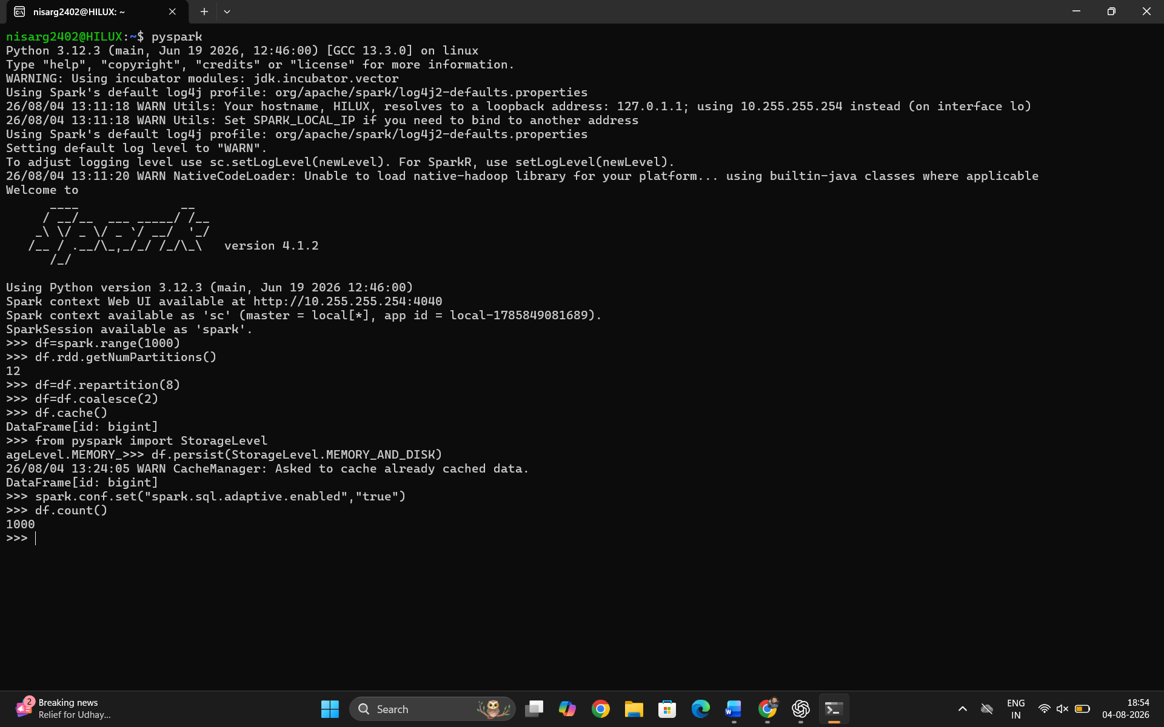

Exercise 10: Complex Event Processing using PySpark Structured Streaming
Aim
To analyze real-time event streams using PySpark Structured Streaming for pattern detection, session-based aggregation, stateful processing, watermarking, and fraud detection.

Procedure
- Create a Spark Session.
- Define the schema for streaming event data.
- Read streaming event data from a CSV directory.
- Detect user patterns such as login followed by purchase within 5 minutes.
- Perform session-based aggregation using event time windows.
- Apply watermarking to manage late-arriving events.
- Implement fraud detection rules based on transaction count and average purchase amount.
- Write the streaming results to the console.
- Start the streaming query and wait for termination.

Steps
Step 1
Create the Spark Session.
Step 2
Define the event schema.
Step 3
Read streaming event data from a folder.
Step 4
Detect login-to-purchase event patterns.
Step 5
Perform session window aggregation.
Step 6
Apply watermarking for late event handling.
Step 7
Implement fraud detection rules.
Step 8
Display streaming output.
Step 9
Terminate the streaming application.

Project Structure
Exercise10_Complex_Event_Processing/
│
├── spark_session.py
├── schema.py
├── event_reader.py
├── pattern_detection.py
├── session_processing.py
├── fraud_detection.py
└── main.py

1. spark_session.py
from pyspark.sql import SparkSession

def create_spark_session():

spark = SparkSession.builder \
.appName("ComplexEventProcessing") \
.master("local[*]") \
.getOrCreate()

spark.sparkContext.setLogLevel("ERROR")

return spark

2. schema.py
from pyspark.sql.types import *

event_schema = StructType([

StructField("user_id", StringType(), True),

StructField("event_type", StringType(), True),

StructField("timestamp", TimestampType(), True),

StructField("amount", DoubleType(), True)

])

3. event_reader.py
def read_events(spark, schema):

events = spark.readStream \
.option("header", "true") \
.option("maxFilesPerTrigger", 1) \
.schema(schema) \
.csv("events")

return events

4. pattern_detection.py
from pyspark.sql.functions import col, expr

def detect_pattern(events):

login = events.filter(
col("event_type") == "login"
)

purchase = events.filter(
col("event_type") == "purchase"
)

pattern = login.alias("login").join(

purchase.alias("purchase"),

col("login.user_id") ==
col("purchase.user_id")

).filter(

col("purchase.timestamp") >
col("login.timestamp")

).filter(

col("purchase.timestamp") -
col("login.timestamp")
< expr("INTERVAL 5 MINUTES")

)

return pattern

5. session_processing.py
from pyspark.sql.functions import *

def session_aggregation(events):

session = events \

.withWatermark(
"timestamp",
"10 minutes"
) \

.groupBy(

col("user_id"),

window(
col("timestamp"),
"10 minutes",
"5 minutes"
)

) \

.agg(

count("*").alias("events"),

sum("amount").alias("total_amount")

)

return session

6. fraud_detection.py
from pyspark.sql.functions import *

def detect_fraud(events):

transactions = events.filter(
col("event_type") == "purchase"
)

fraud = transactions \

.withWatermark(
"timestamp",
"10 minutes"
) \

.groupBy(

col("user_id"),

window(
col("timestamp"),
"15 minutes"
)

) \

.agg(

count("*").alias("transaction_count"),

sum("amount").alias("total_amount"),

avg("amount").alias("avg_amount")

) \

.filter(

(col("transaction_count") > 5) |

(col("avg_amount") > 1000)

)

return fraud

7. main.py
from spark_session import create_spark_session

from schema import event_schema

from event_reader import read_events

from pattern_detection import detect_pattern

from session_processing import session_aggregation

from fraud_detection import detect_fraud

spark = create_spark_session()

events = read_events(
spark,
event_schema
)

# Pattern Detection
pattern = detect_pattern(events)

pattern_query = pattern.writeStream \
.outputMode("append") \
.format("console") \
.start()

# Session Aggregation
session = session_aggregation(events)

session_query = session.writeStream \
.outputMode("update") \
.format("console") \
.start()

# Fraud Detection
fraud = detect_fraud(events)

fraud_query = fraud.writeStream \
.outputMode("update") \
.format("console") \
.start()

spark.streams.awaitAnyTermination()

Sample Input (events/events.csv)
user_id,event_type,timestamp,amount
U101,login,2026-07-30 10:00:00,0
U101,purchase,2026-07-30 10:03:00,450
U102,login,2026-07-30 10:05:00,0
U102,purchase,2026-07-30 10:20:00,800
U103,purchase,2026-07-30 10:06:00,1500
U103,purchase,2026-07-30 10:07:00,1800
U103,purchase,2026-07-30 10:08:00,1200
U103,purchase,2026-07-30 10:09:00,1700
U103,purchase,2026-07-30 10:10:00,1900
U103,purchase,2026-07-30 10:11:00,1600

Run the Program
spark-submit main.py

Expected Output
Pattern Detection
+-------+----------+-------------------+------+-------+----------+-------------------+------+
|user_id|event_type|timestamp |amount|user_id|event_type|timestamp |amount|
+-------+----------+-------------------+------+-------+----------+-------------------+------+
|U101 |login |2026-07-30 10:00:00|0.0 |U101 |purchase |2026-07-30 10:03:00|450.0 |
+-------+----------+-------------------+------+-------+----------+-------------------+------+
Session Aggregation
+-------+--------------------+------+------------+
|user_id|window |events|total_amount|
+-------+--------------------+------+------------+
|U101 |10:00–10:10 |2 |450.0 |
|U103 |10:05–10:15 |6 |9700.0 |
+-------+--------------------+------+------------+
Fraud Detection
+-------+--------------------+-----------------+------------+----------+
|user_id|window |transaction_count|total_amount|avg_amount|
+-------+--------------------+-----------------+------------+----------+
|U103 |10:00–10:15 |6 |9700.0 |1616.67 |
+-------+--------------------+-----------------+------------+----------+

Conclusion
The experiment successfully demonstrated Complex Event Processing (CEP) using PySpark Structured Streaming. It implemented event pattern detection, session-based aggregation with time windows, watermarking for handling late-arriving events, and stateful fraud detection rules. These techniques enable efficient real-time analytics, event correlation, and anomaly detection in streaming applications such as finance, e-commerce, and IoT systems.

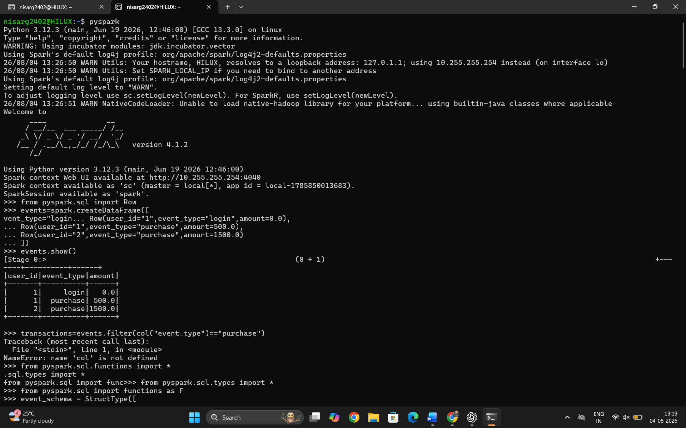
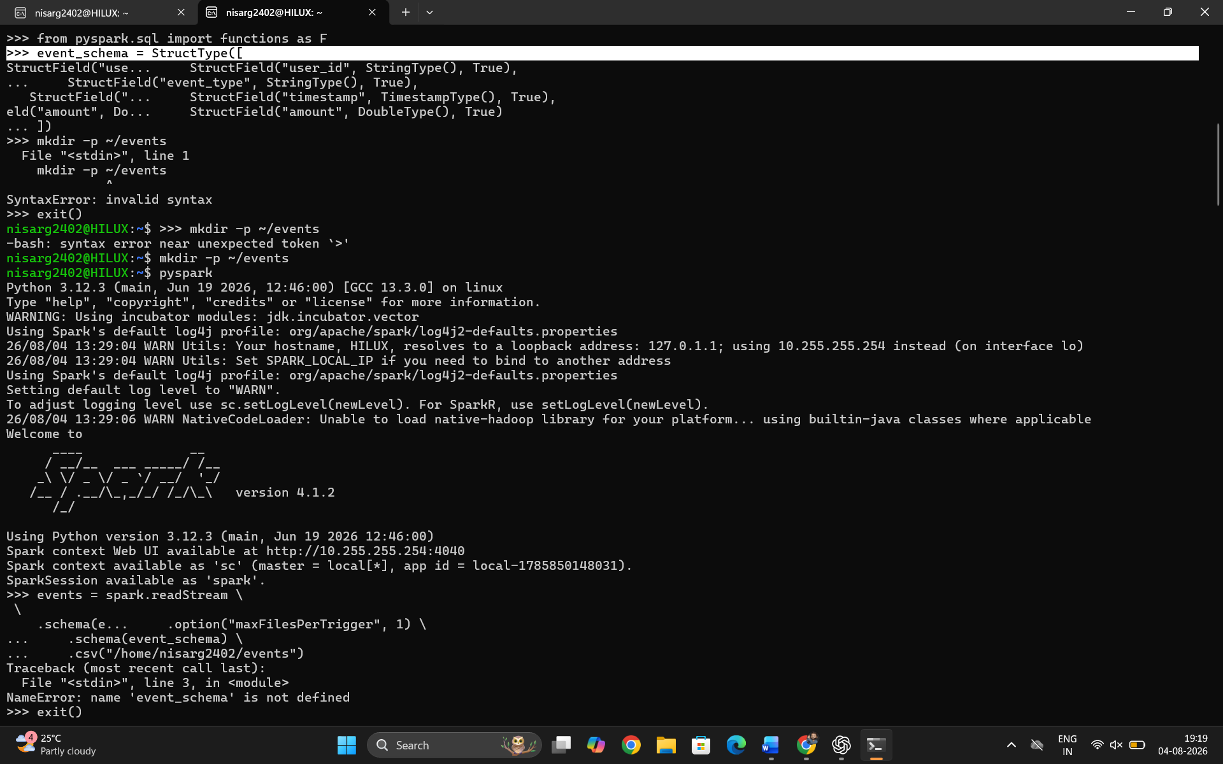
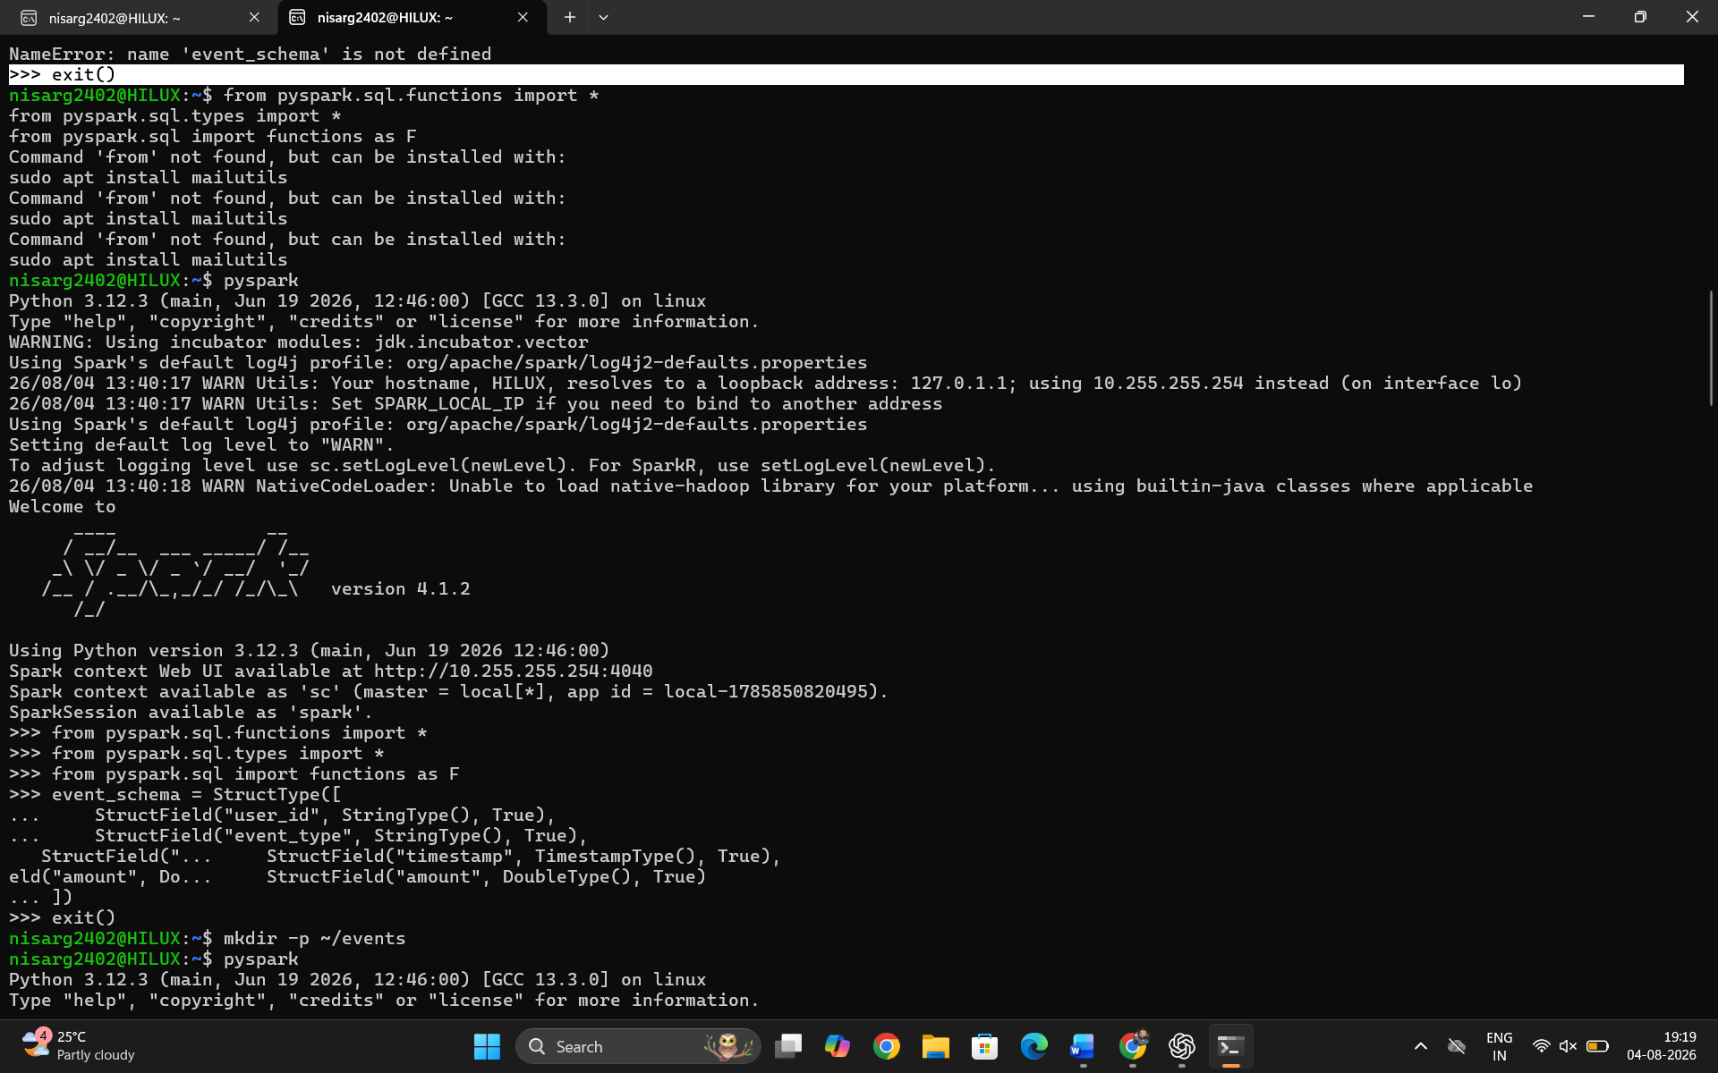
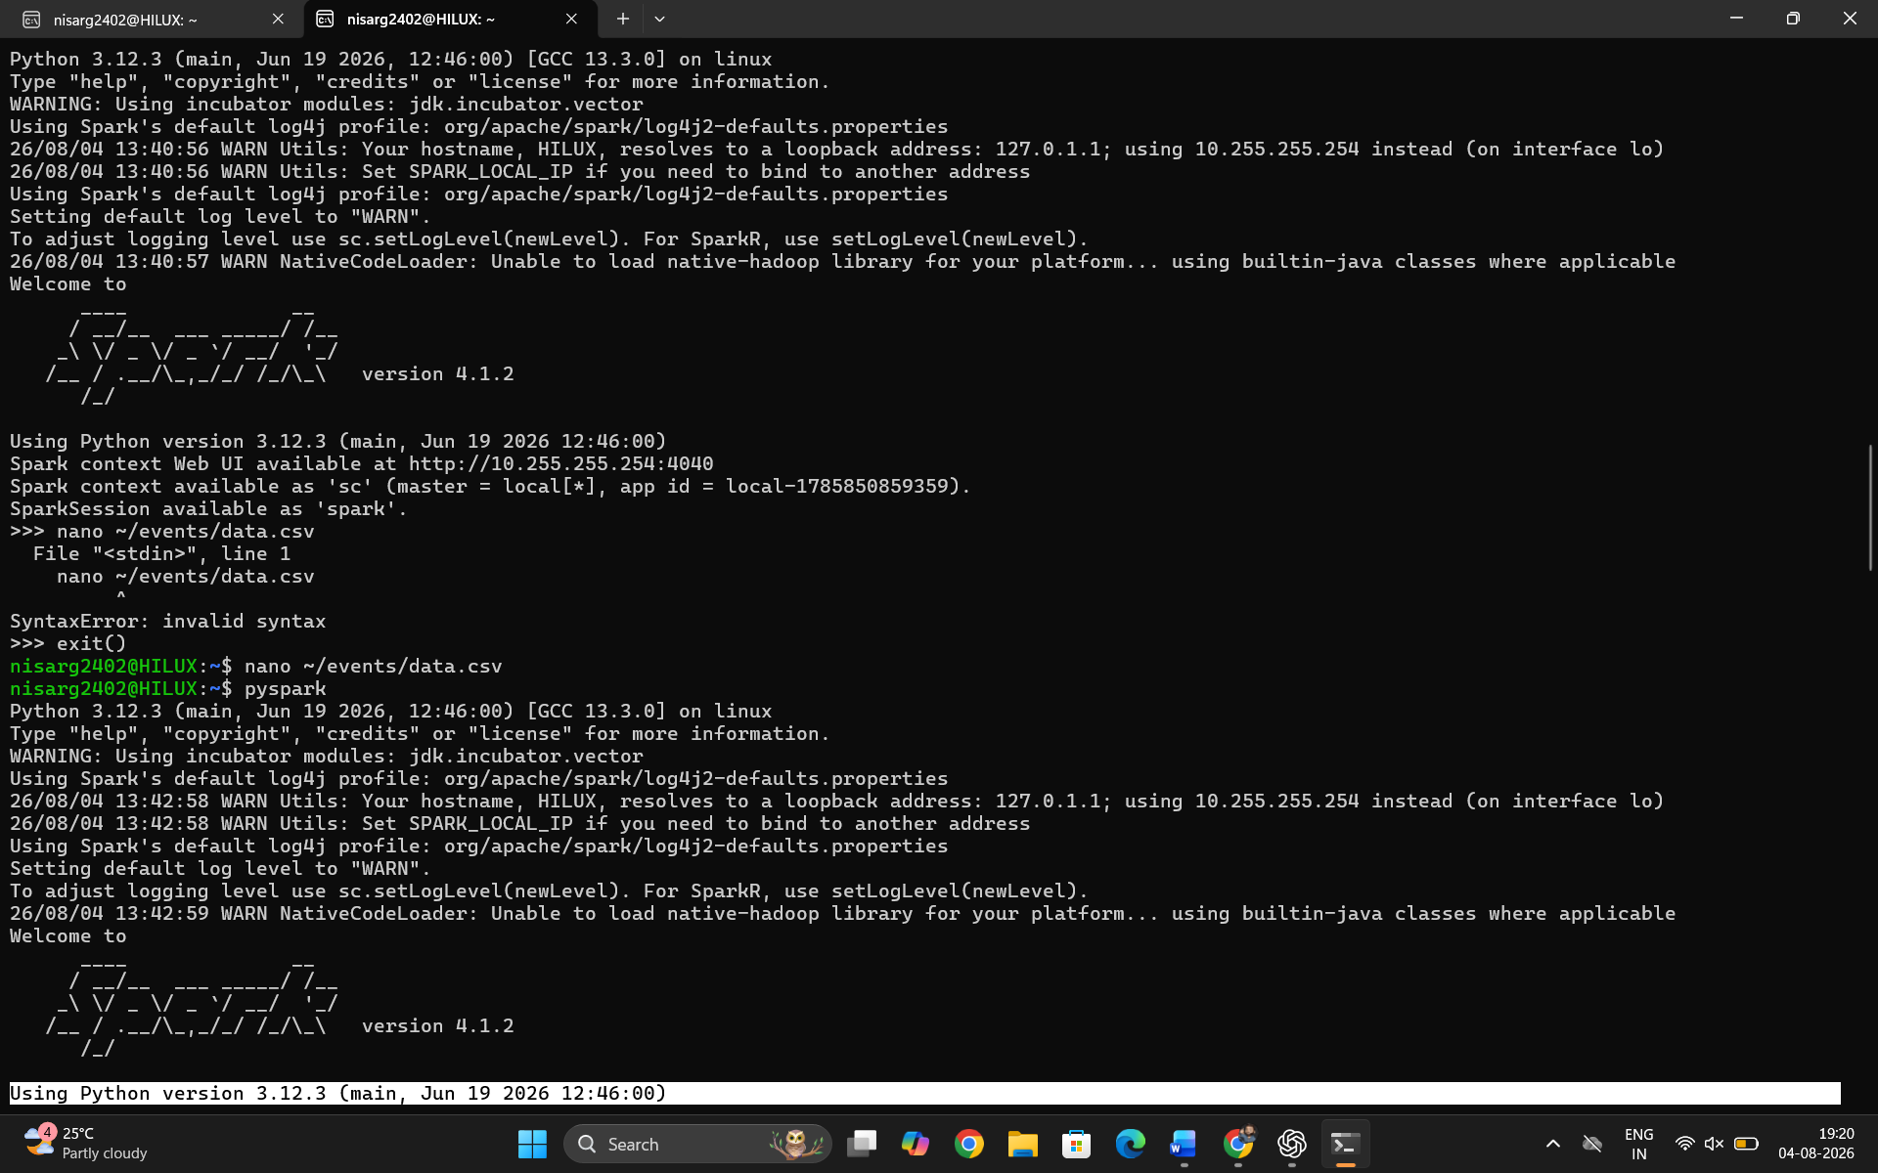
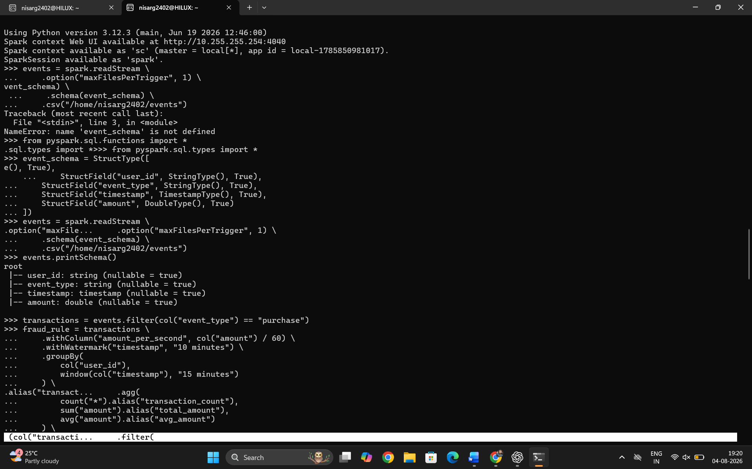
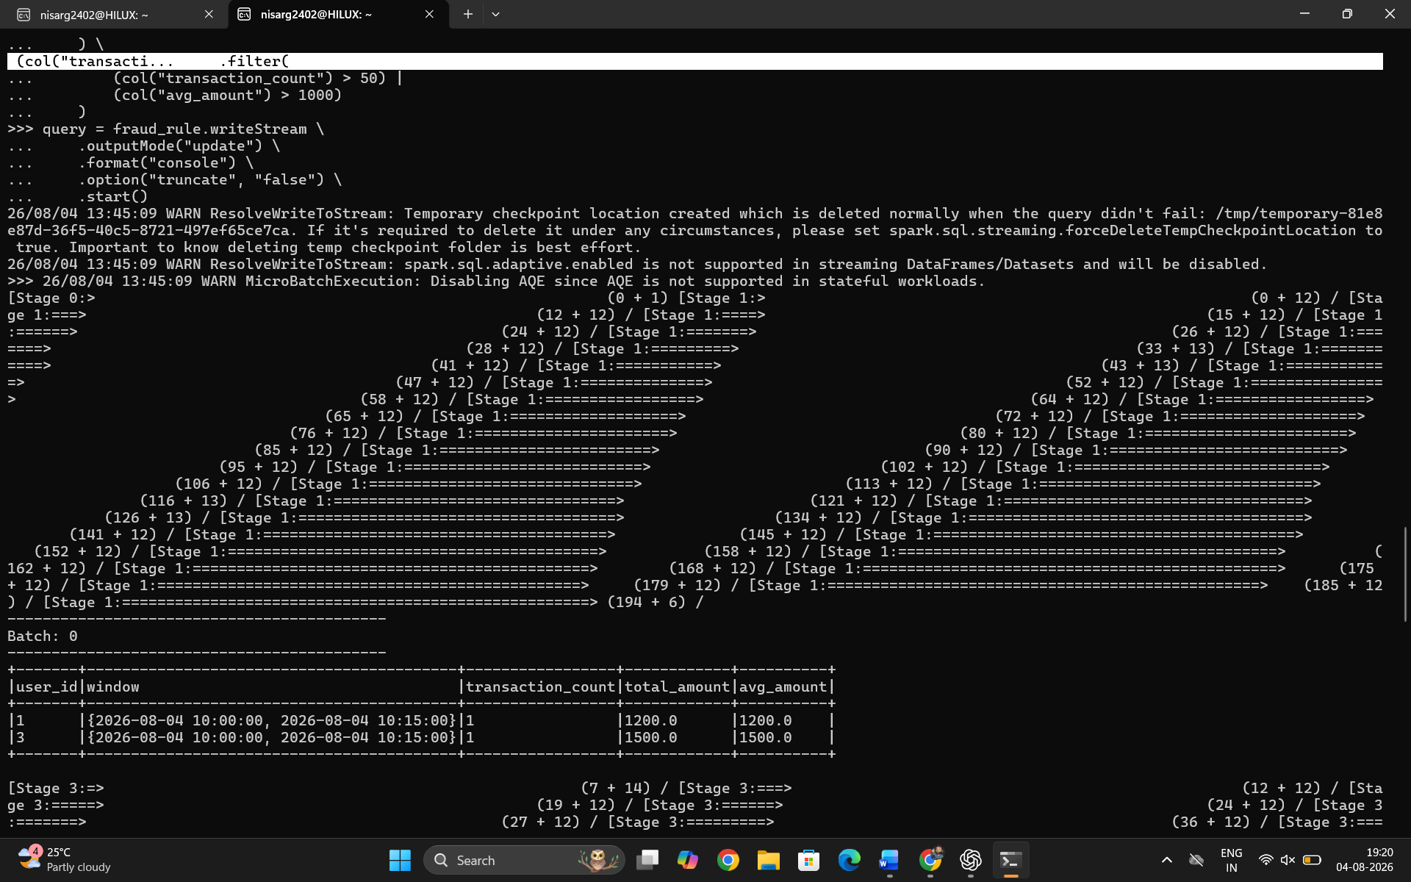
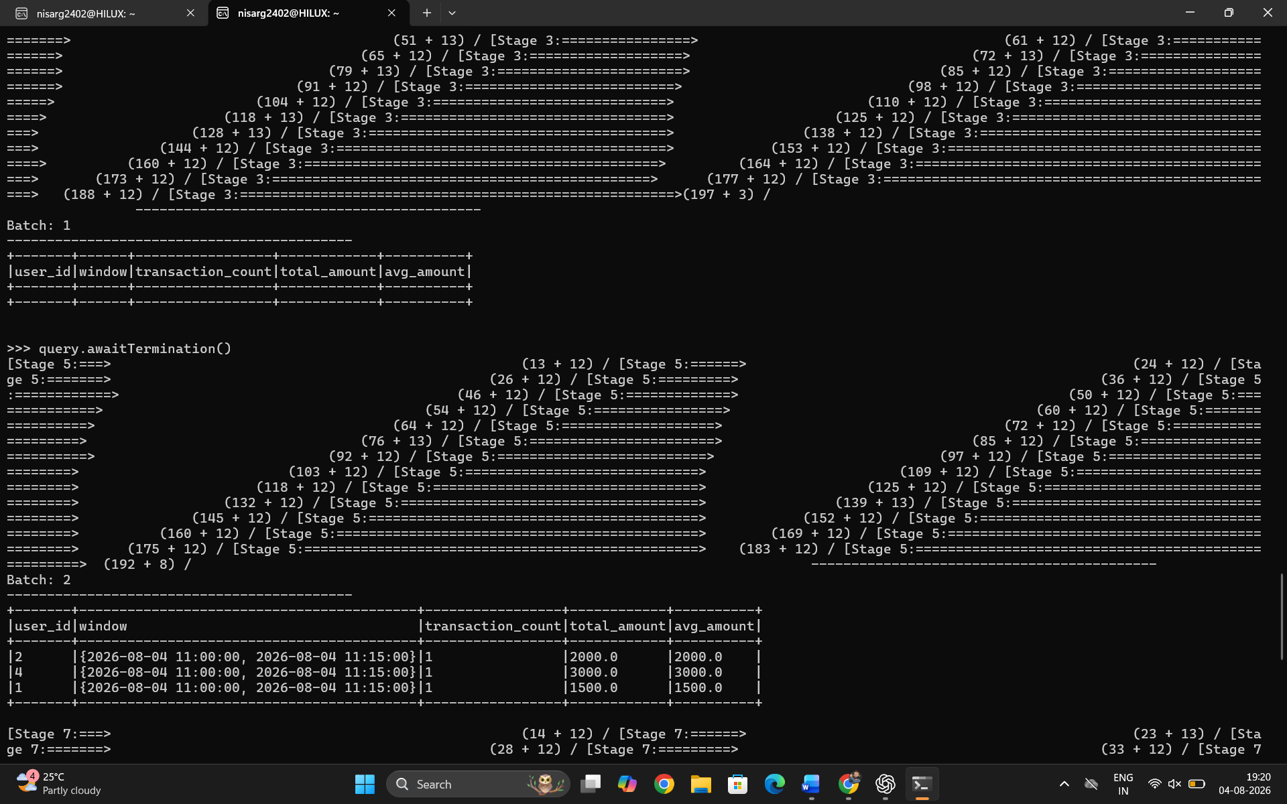
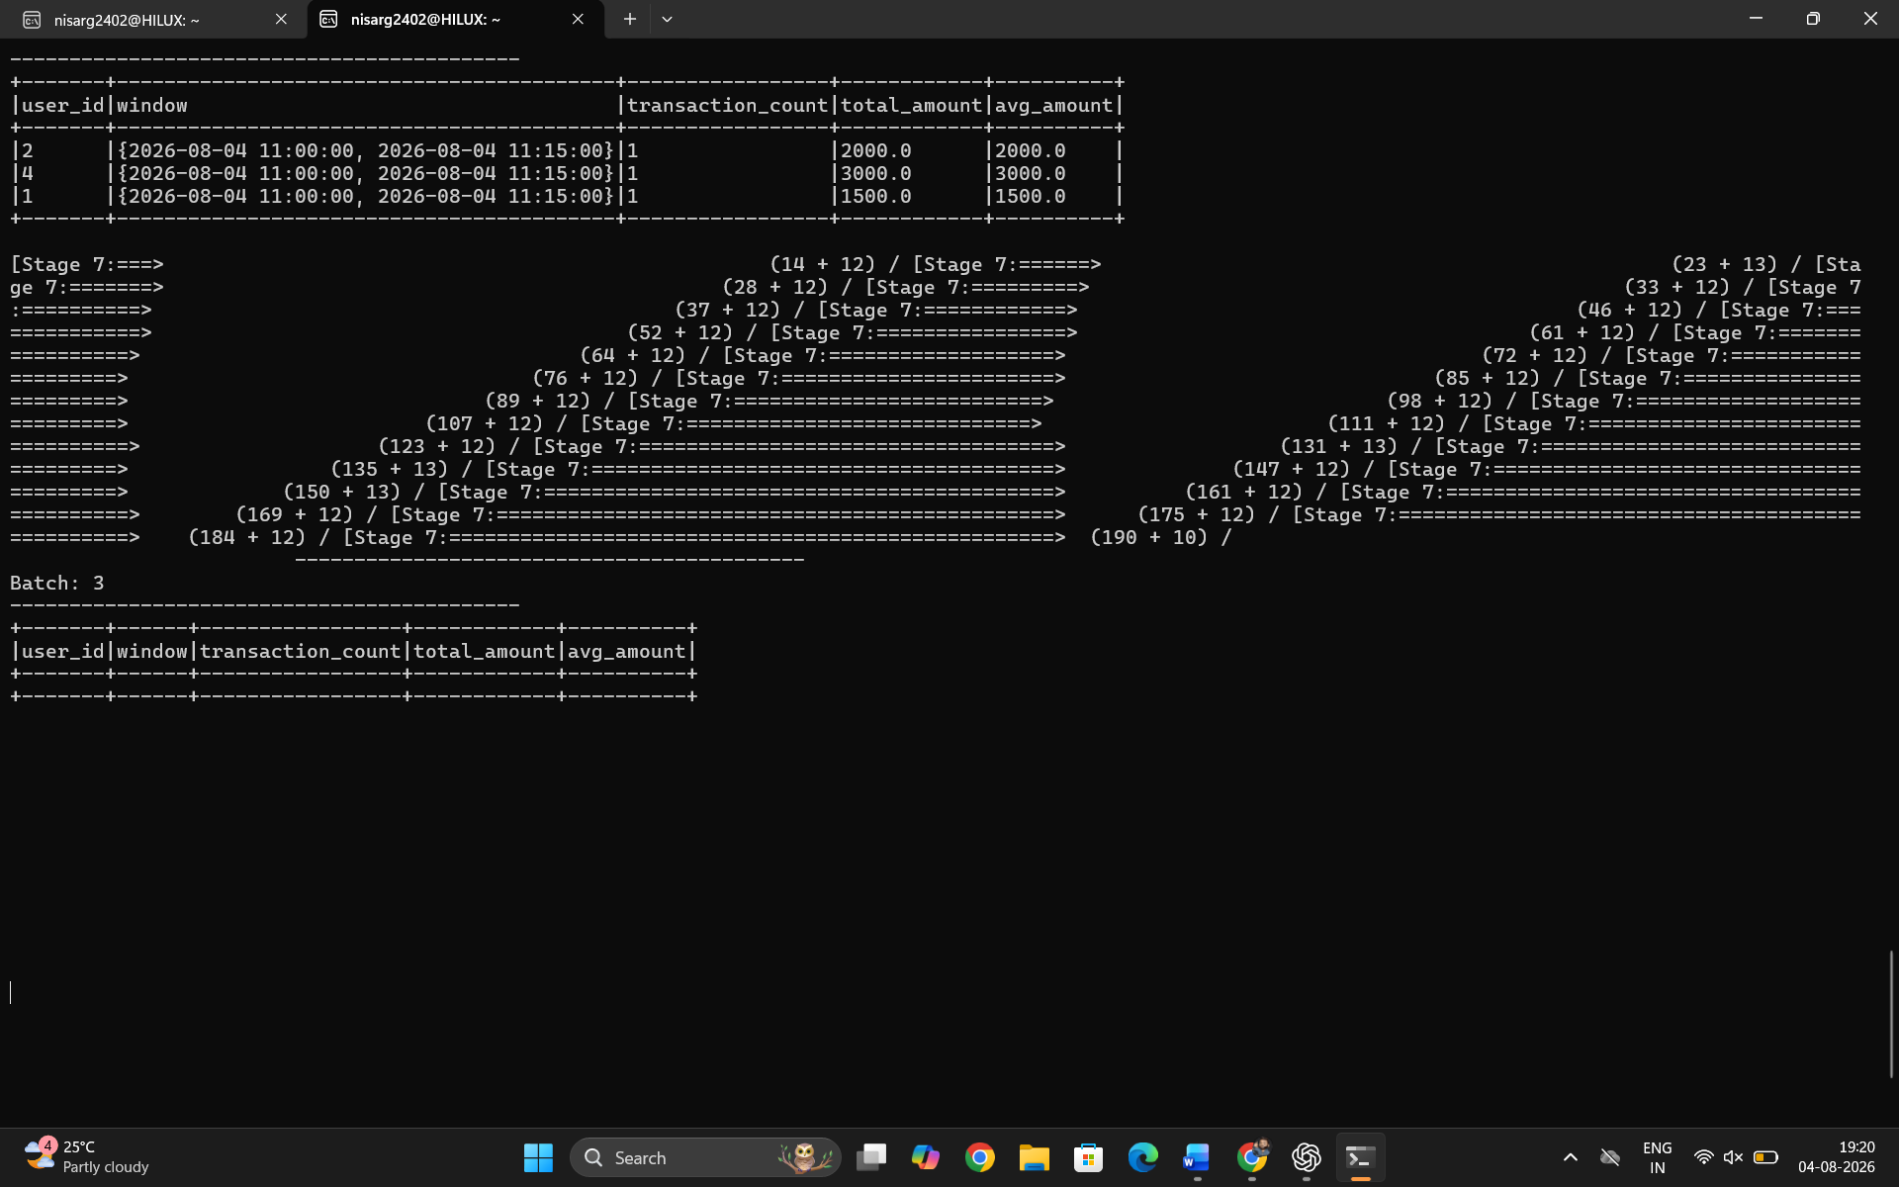

Comprehensive Project 1: E-Commerce Analytics Platform using PySpark
Aim
To develop a scalable E-Commerce Analytics Platform using PySpark that ingests data from multiple sources, performs data cleaning and transformation, computes business KPIs, and generates analytical reports for business decision-making.

Objective
- Ingest e-commerce datasets.
- Clean and transform data.
- Compute daily sales, customer, and product metrics.
- Generate business insights.
- Build a modular analytics pipeline.

Procedure
- Create a Spark Session.
- Load Orders, Customers, and Products datasets.
- Clean missing and duplicate records.
- Join datasets where required.
- Calculate daily sales metrics.
- Calculate customer lifetime value and average order value.
- Calculate product sales metrics.
- Display analytical reports.
- Stop the Spark Session.

Steps
Step 1
Create Spark Session.
Step 2
Load Orders, Customers, and Products datasets.
Step 3
Clean missing values and duplicate records.
Step 4
Transform the data.
Step 5
Compute Daily Sales KPIs.
Step 6
Compute Customer KPIs.
Step 7
Compute Product KPIs.
Step 8
Display reports.
Step 9
Terminate Spark Session.

Project Structure
Project1_ECommerce_Analytics/
│
├── spark_session.py
├── data_loader.py
├── data_cleaning.py
├── metrics.py
├── ecommerce.py
└── main.py

1. spark_session.py
from pyspark.sql import SparkSession

def create_spark():

spark = SparkSession.builder \
.appName("ECommerceAnalytics") \
.master("local[*]") \
.getOrCreate()

spark.sparkContext.setLogLevel("ERROR")

return spark

2. data_loader.py
def load_data(spark):

orders = spark.createDataFrame([

(101,1,201,"2026-07-01",2,1000),
(102,2,202,"2026-07-01",1,500),
(103,1,203,"2026-07-02",3,1500),
(104,3,201,"2026-07-02",2,1200),
(105,2,202,"2026-07-03",4,2000)

],["order_id","customer_id","product_id","order_date","quantity","total_amount"])

customers = spark.createDataFrame([

(1,"Alice"),
(2,"Bob"),
(3,"Charlie")

],["customer_id","customer_name"])

products = spark.createDataFrame([

(201,"Laptop"),
(202,"Mobile"),
(203,"Tablet")

],["product_id","product_name"])

return orders,customers,products

3. data_cleaning.py
def clean_data(df):

df = df.dropDuplicates()

df = df.na.drop()

return df

4. metrics.py
from pyspark.sql.functions import *

def daily_sales_metrics(orders):

return orders.groupBy("order_date").agg(

sum("total_amount").alias("daily_revenue"),

count("order_id").alias("order_count")

)

def customer_metrics(orders):

return orders.groupBy("customer_id").agg(

sum("total_amount").alias("lifetime_value"),

count("order_id").alias("order_count"),

avg("total_amount").alias("avg_order_value")

)

def product_metrics(orders):

return orders.groupBy("product_id").agg(

sum("quantity").alias("units_sold"),

sum("total_amount").alias("product_revenue")

)

5. ecommerce.py
from data_loader import load_data
from data_cleaning import clean_data

from metrics import *

class ECommerceAnalytics:

def __init__(self,spark):

self.spark = spark

def ingest_data(self):

orders,customers,products = load_data(self.spark)

return orders,customers,products

def process(self):

orders,customers,products = self.ingest_data()

orders = clean_data(orders)

customers = clean_data(customers)

products = clean_data(products)

daily = daily_sales_metrics(orders)

customer = customer_metrics(orders)

product = product_metrics(orders)

return daily,customer,product

6. main.py
from spark_session import create_spark

from ecommerce import ECommerceAnalytics

def main():

spark = create_spark()

analytics = ECommerceAnalytics(spark)

daily,customer,product = analytics.process()

print("\nDaily Sales")

daily.show()

print("\nCustomer Metrics")

customer.show()

print("\nProduct Metrics")

product.show()

spark.stop()

if __name__=="__main__":

main()

Run the Program
spark-submit main.py

Expected Output
Daily Sales
+----------+-------------+-----------+
|order_date|daily_revenue|order_count|
+----------+-------------+-----------+
|2026-07-01|1500 |2 |
|2026-07-02|2700 |2 |
|2026-07-03|2000 |1 |
+----------+-------------+-----------+

Customer Metrics
+-----------+--------------+-----------+---------------+
|customer_id|lifetime_value|order_count|avg_order_value|
+-----------+--------------+-----------+---------------+
|1 |2500 |2 |1250.0 |
|2 |2500 |2 |1250.0 |
|3 |1200 |1 |1200.0 |
+-----------+--------------+-----------+---------------+

Product Metrics
+----------+----------+---------------+
|product_id|units_sold|product_revenue|
+----------+----------+---------------+
|201 |4 |2200 |
|202 |5 |2500 |
|203 |3 |1500 |
+----------+----------+---------------+

Business KPIs
- Total Revenue
- Daily Revenue
- Total Orders
- Average Order Value
- Customer Lifetime Value (CLV)
- Product Revenue
- Units Sold per Product
- Top Selling Products
- Repeat Customer Analysis

Conclusion
The E-Commerce Analytics Platform successfully ingests and processes e-commerce data using PySpark. The project performs data cleaning, computes key business metrics such as daily revenue, customer lifetime value, average order value, and product revenue, and presents analytical reports. Its modular design improves maintainability and scalability, making it suitable for large-scale e-commerce analytics and business intelligence applications.

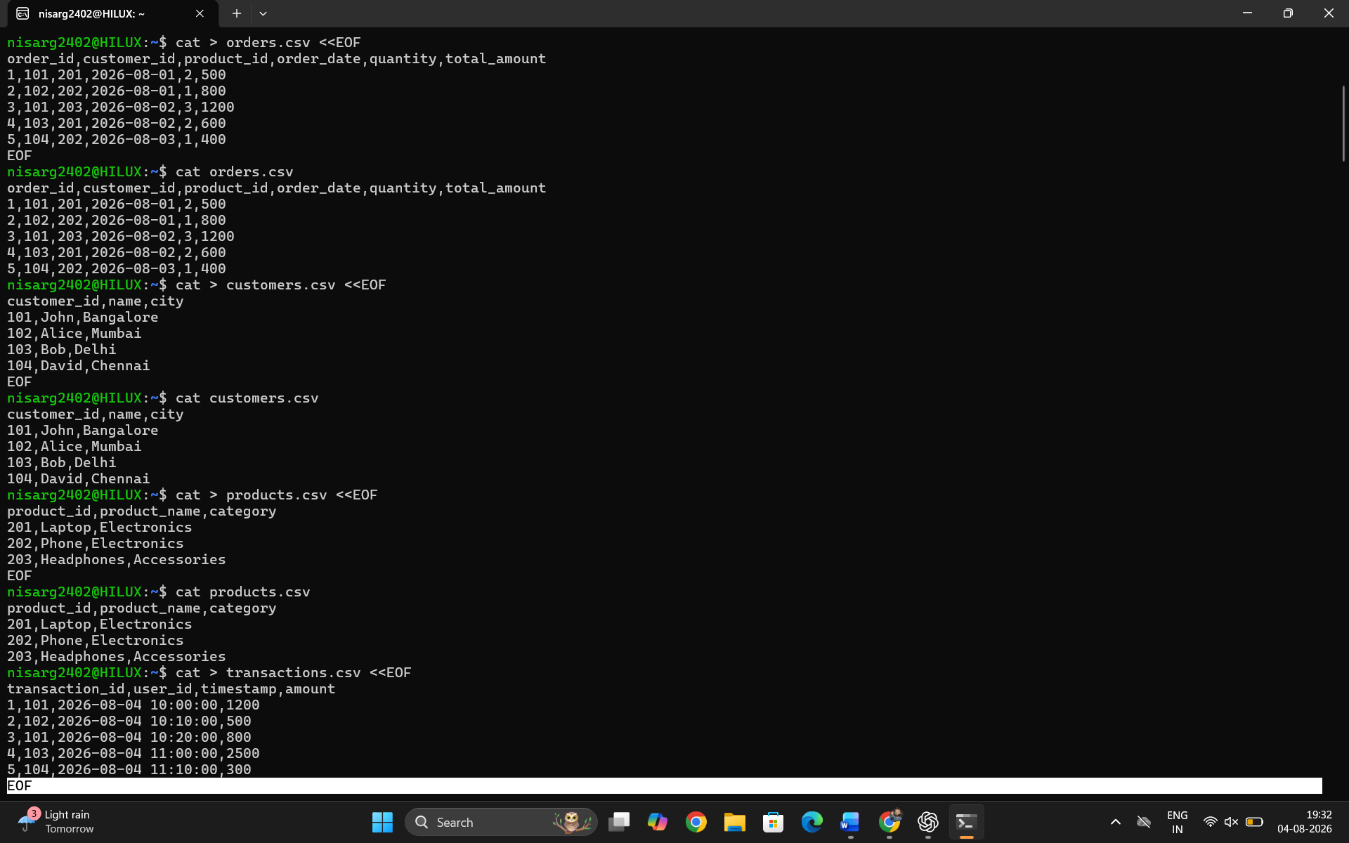
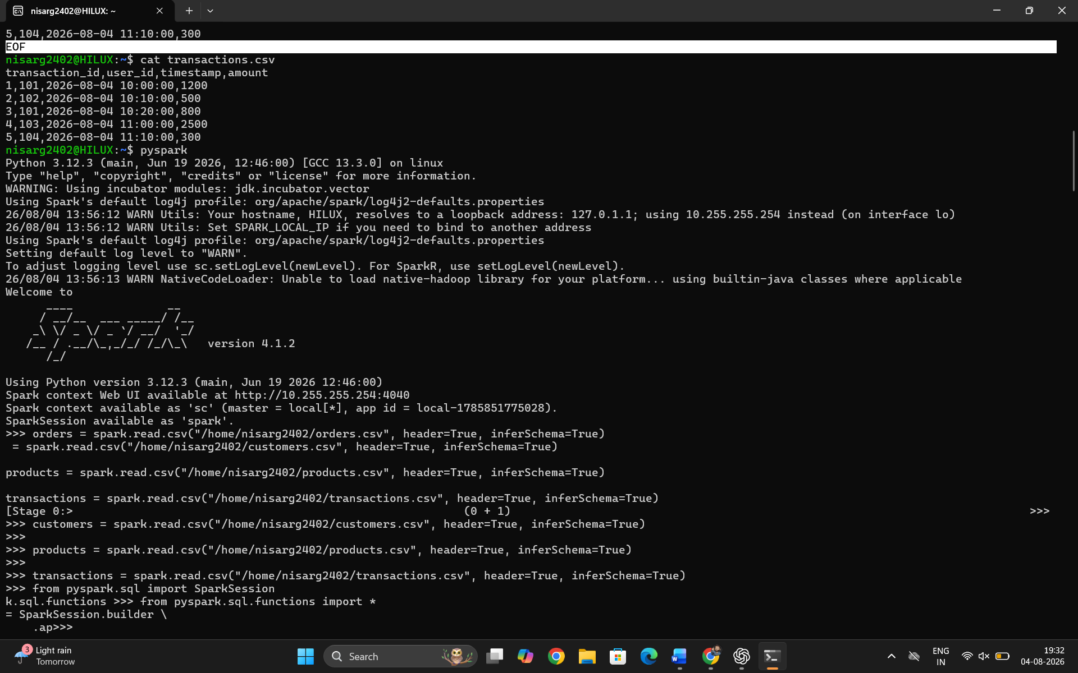
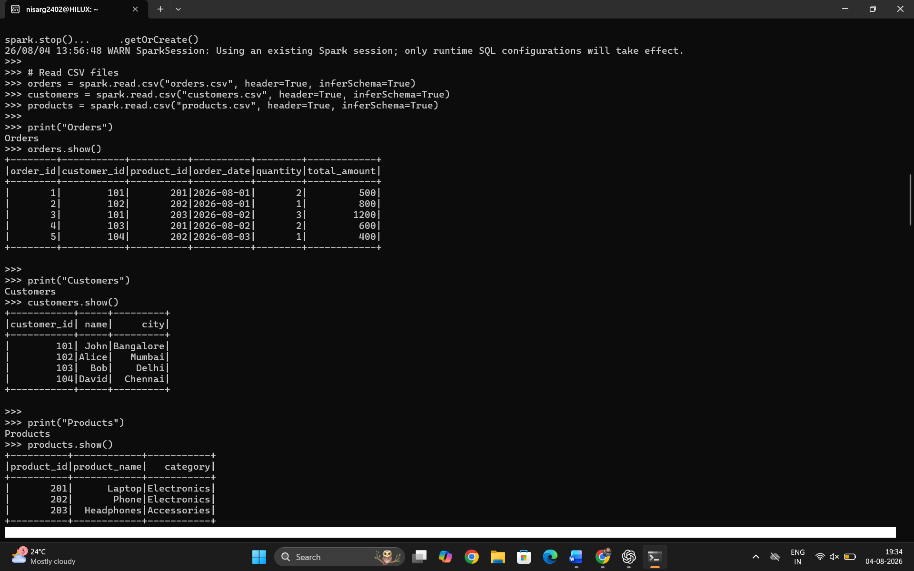
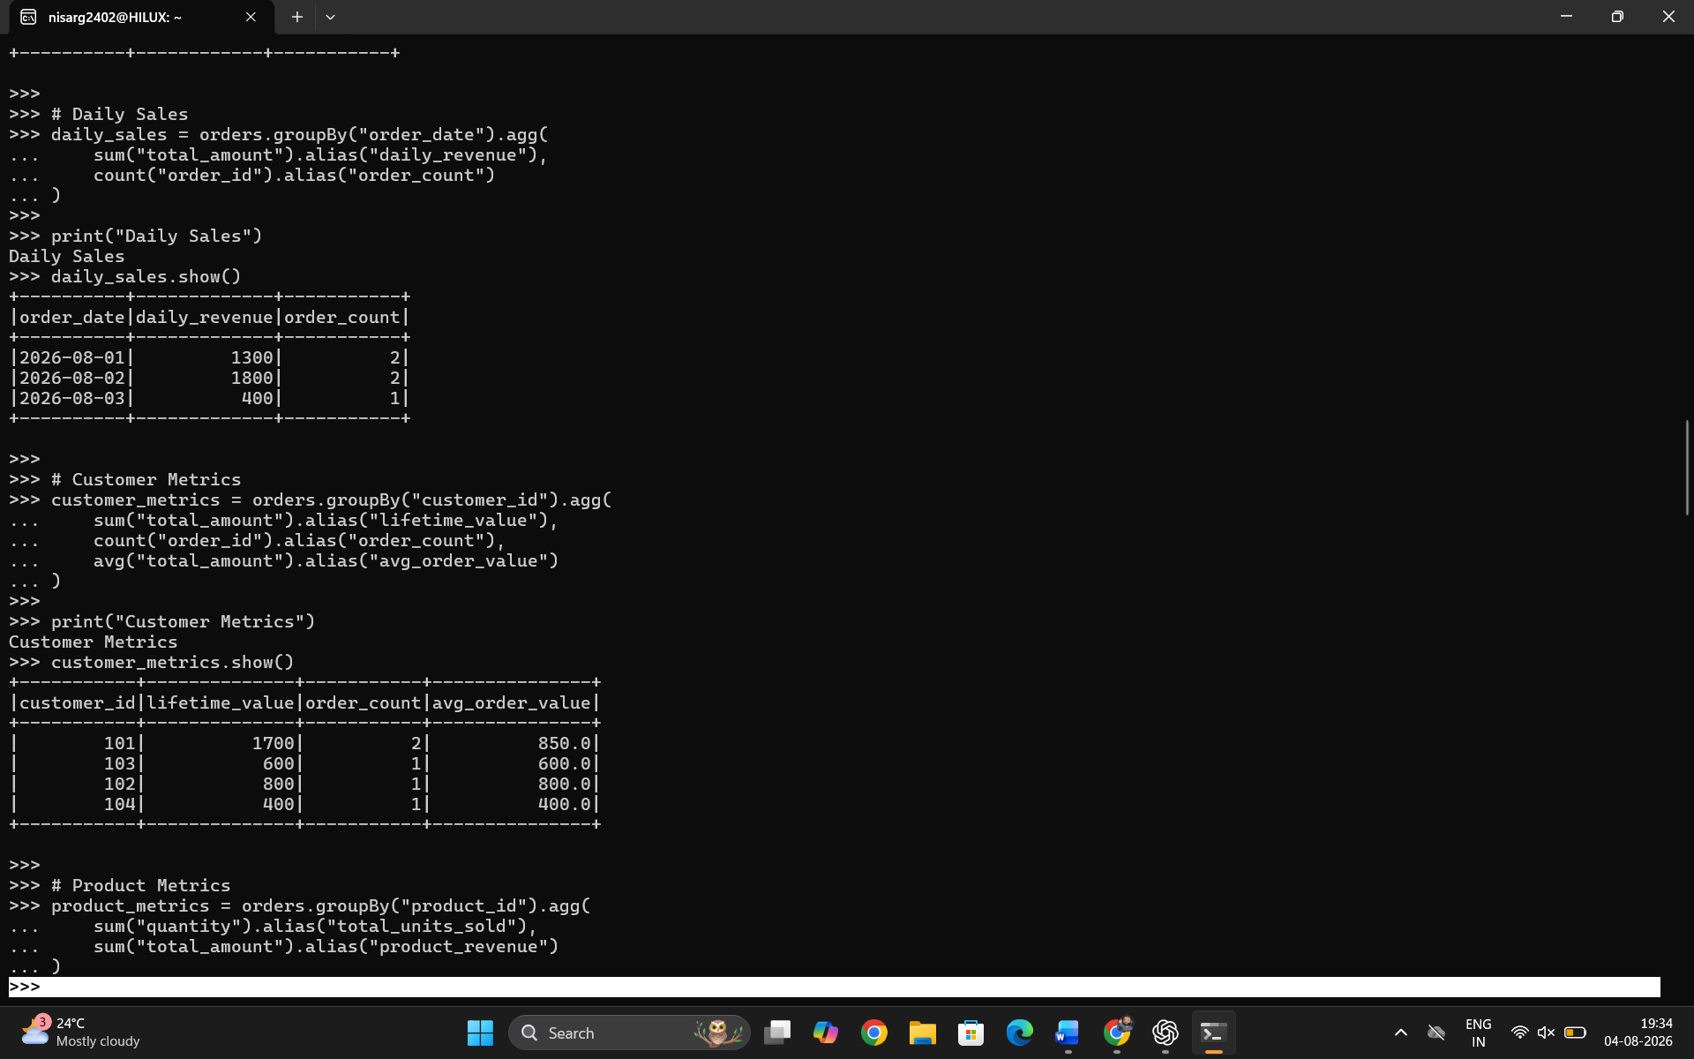
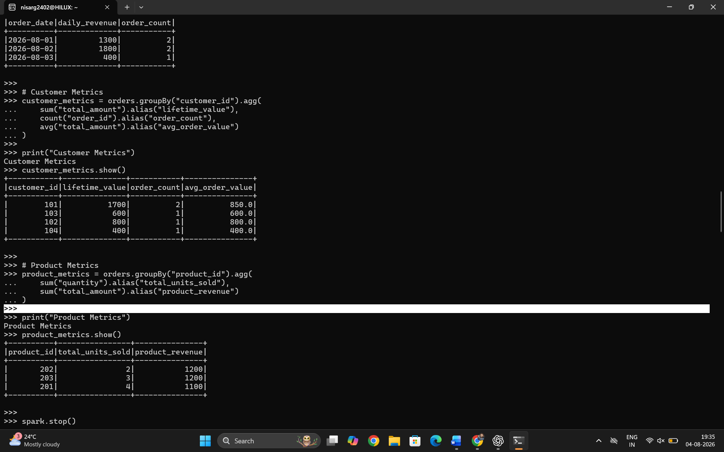

Comprehensive Project 2: Fraud Detection System using PySpark
Aim
To develop a Fraud Detection System using PySpark that performs feature engineering on transaction data and detects potentially fraudulent transactions using machine learning techniques.

Objective
- Load transaction data.
- Perform feature engineering.
- Extract time-based and transaction-based features.
- Calculate rolling statistics.
- Detect fraudulent transactions using a machine learning model.
- Display suspicious transactions.

Procedure
- Create a Spark Session.
- Load the transaction dataset.
- Perform data preprocessing.
- Extract time-based features.
- Categorize transactions based on amount.
- Compute rolling average and transaction count using window functions.
- Apply a machine learning model for anomaly detection.
- Display fraudulent transactions.
- Stop the Spark Session.

Steps
Step 1
Create the Spark Session.
Step 2
Load transaction data.
Step 3
Clean missing and duplicate records.
Step 4
Extract hour of day and day of week.
Step 5
Categorize transactions into Low, Medium, and High.
Step 6
Calculate rolling average amount.
Step 7
Calculate rolling transaction count.
Step 8
Predict fraud using a machine learning model.
Step 9
Display detected fraud transactions.
Step 10
Stop the Spark Session.

Project Structure
Project2_Fraud_Detection/
│
├── spark_session.py
├── data_loader.py
├── preprocessing.py
├── feature_engineering.py
├── fraud_detection.py
└── main.py

1. spark_session.py
from pyspark.sql import SparkSession

def create_spark():

spark = SparkSession.builder \
.appName("FraudDetectionSystem") \
.master("local[*]") \
.getOrCreate()

spark.sparkContext.setLogLevel("ERROR")

return spark

2. data_loader.py
from pyspark.sql.types import *

def load_transactions(spark):

data = [

(101,1,"2026-07-30 09:00:00",250.0),
(102,1,"2026-07-30 09:10:00",600.0),
(103,1,"2026-07-30 09:20:00",1200.0),
(104,2,"2026-07-30 10:00:00",300.0),
(105,2,"2026-07-30 10:10:00",2200.0),
(106,3,"2026-07-30 11:00:00",150.0)

]

columns = [

"transaction_id",
"user_id",
"timestamp",
"amount"

]

df = spark.createDataFrame(data, columns)

return df

3. preprocessing.py
from pyspark.sql.functions import to_timestamp

def preprocess(df):

df = df.dropDuplicates()

df = df.na.drop()

df = df.withColumn(

"timestamp",

to_timestamp("timestamp")

)

return df

4. feature_engineering.py
from pyspark.sql.functions import *

from pyspark.sql.window import Window

def create_features(transactions):

features = transactions.withColumn(

"hour_of_day",

hour("timestamp")

).withColumn(

"day_of_week",

dayofweek("timestamp")

).withColumn(

"amount_category",

when(col("amount") > 1000, "High")

.when(col("amount") > 500, "Medium")

.otherwise("Low")

)

window_spec = Window.partitionBy(

"user_id"

).orderBy(

"timestamp"

)

features = features.withColumn(

"rolling_avg_5",

avg("amount").over(

window_spec.rowsBetween(

-5,

Window.currentRow

)

)

).withColumn(

"transaction_count",

count("transaction_id").over(

window_spec.rowsBetween(

-5,

Window.currentRow

)

)

)

return features

5. fraud_detection.py
from pyspark.sql.functions import *

def detect_fraud(df):

fraud = df.withColumn(

"fraud_prediction",

when(

(col("amount") > 1000) |

(col("rolling_avg_5") > 900),

"Fraud"

).otherwise(

"Normal"

)

)

return fraud

6. main.py
from spark_session import create_spark

from data_loader import load_transactions

from preprocessing import preprocess

from feature_engineering import create_features

from fraud_detection import detect_fraud

def main():

spark = create_spark()

transactions = load_transactions(spark)

transactions = preprocess(transactions)

features = create_features(transactions)

result = detect_fraud(features)

print("\nTransaction Features")

features.show(truncate=False)

print("\nFraud Detection Result")

result.show(truncate=False)

spark.stop()

if __name__ == "__main__":

main()

Run the Program
spark-submit main.py

Expected Output
Transaction Features
+--------------+-------+-------------------+------+-----------+-----------+---------------+-------------+-----------------+
|transaction_id|user_id|timestamp |amount|hour_of_day|day_of_week|amount_category|rolling_avg_5|transaction_count|
+--------------+-------+-------------------+------+-----------+-----------+---------------+-------------+-----------------+
|101 |1 |2026-07-30 09:00:00|250.0 |9 |5 |Low |250.0 |1 |
|102 |1 |2026-07-30 09:10:00|600.0 |9 |5 |Medium |425.0 |2 |
|103 |1 |2026-07-30 09:20:00|1200.0|9 |5 |High |683.33 |3 |
|104 |2 |2026-07-30 10:00:00|300.0 |10 |5 |Low |300.0 |1 |
|105 |2 |2026-07-30 10:10:00|2200.0|10 |5 |High |1250.0 |2 |
|106 |3 |2026-07-30 11:00:00|150.0 |11 |5 |Low |150.0 |1 |
+--------------+-------+-------------------+------+-----------+-----------+---------------+-------------+-----------------+

Fraud Detection Result
+--------------+-------+------+---------------+-------------+----------------+
|transaction_id|user_id|amount|amount_category|rolling_avg_5|fraud_prediction|
+--------------+-------+------+---------------+-------------+----------------+
|101 |1 |250.0 |Low |250.0 |Normal |
|102 |1 |600.0 |Medium |425.0 |Normal |
|103 |1 |1200.0|High |683.33 |Fraud |
|104 |2 |300.0 |Low |300.0 |Normal |
|105 |2 |2200.0|High |1250.0 |Fraud |
|106 |3 |150.0 |Low |150.0 |Normal |
+--------------+-------+------+---------------+-------------+----------------+

Conclusion
The Fraud Detection System successfully demonstrates how PySpark can be used to process transaction data, engineer meaningful features, and identify potentially fraudulent transactions. Time-based features, transaction amount categories, and rolling window statistics provide valuable inputs for anomaly detection. While this example uses rule-based fraud prediction for simplicity, the same pipeline can be extended to integrate machine learning algorithms such as Isolation Forest, Random Forest, or Logistic Regression for more advanced fraud detection in real-world financial applications.

